**Contents**

List of Figures 2

Introduction 5

Research Methodology 5

Literature Search 5

Selection Criteria 6

Background Research 6

History of NLP 7

Machine learning in NLP 8

The Role of NLP in Enhancing Access to Justice 11

Identifying and Mitigating Bias 12

Privacy and Security Concerns in Legal NLP Applications 12

Current Trends and Future Directions of NLP in law 13

Market Analysis 15

The Existing Market of household and Tenant law 15

Existing Solutions for Household and Tenant Law 15

Project Proposal 17

Project Details: 17

Project Specification/Objectives: 17

Project Functional and Non-Functional Requirements 18

Project User Stories 19

High Level System Design: 23

Requirement Analysis: 24

MoSCoW Analysis 24

Project System Requirement: 25

Traceability Matrix: 27

Project Solution 28

Assumptions, Constraints, Risks: 28

Solution Description: 31

Project Management Approach: 31

Agile Methodology 31

Project Management Using Scrum Framework 31

Scrum Sprints 32

Project Management Tools 33

Design Phase: 35

Wireframes: 35

Database Design: 37

Dataset Workflow/Design: 39

LLD Design: 40

Implementation: 42

Database Implementation and Connection: 42

Front-end Implementation: 44

Backend-Server Side: 46

NLP Model Implementation: 51

Testing: 63

Unit Testing 63

Designing the Unit Tests Using Pytest: 63

Unit Tests Outcome: 68

Unit Tests Outcome Discussion: 70

Integration Testing Plan: 71

Integration Testing Outcomes: 72

Evaluation: 73

Future Work: 74

Conclusion: 75

References 77

Dataset Document Reference: 79

# List of Figures

Figure 1 Showing the Hierarchy of NLP 8

Figure 2 Showing the Development of NLP overtime 10

Figure 3 Showing the Overlap of NLP with ML and DL 15

Figure 4 Showing the NLP Pipeline 16

Figure 5 Showing User Registration Use Case 20

Figure 6 Showing User Login Use Case 21

Figure 7 Showing User Legal Advice Use Case 21

Figure 8 Showing User Chat History Review Use Case 21

Figure 9 Showing User Providing Feedback Use Case 21

Figure 10 Showing User Logout Use Case 22

Figure 11Showing General Overview of the Application 22

Figure 12 Showing HLD Design of Litigat8 23

Figure 13 Showing Different Layers of Litigat8 25

Figure 14 Showing Trello Board for litigat8- 2 29

Figure 15 Showing Project Timline Managment Using Gantt Chart for Litigat8 -1 29

Figure 16 Showing Trello Board for litigat8- 1 29

Figure 17 Showing Project Timeline Management Using Gantt Chart for Litigat8 -2 30

Figure 18 Showing Project Timeline Management Using Gantt Chart for Litigat8 - 3 30

Figure 19 Showing Registration Wireframe 31

Figure 20 Showing Login Wireframe 32

Figure 21 Showing Main Chat Interface Wireframe 32

Figure 22 Showing **User Model** 33

Figure 23 Showing **ChatSession Model** 33

Figure 24 Showing **Conversation Model** 33

Figure 25 Showing the ERD Diagram for Litigat8 Database 33

Figure 26 Showing the Framework for the Data Collection and Preparation for Litigat8 Training 34

Figure 27 Showing the Low-Level Design (LLD) for Litigat8 35

Figure 28 Showing the Setup of Database Config 36

Figure 29 Setting up the Database 36

Figure 30 Setting up the Models for Database 37

Figure 31 Showing the constructed Table in the Litigate Database 37

Figure 32 Showing the Front-end Implementation of Main-Page 38

Figure 33 Showing the Front-end Implementation of Login Page of Litigate 39

Figure 34 Showing the Front-end Implementation of Register Page of Litigate 40

Figure 35 Showing the Front-end Implementation Chat Interface of Litigate 40

Figure 36 Showing the implementation of Flask App with Configuration 41

Figure 37 Showing the Implementation of Auth Blueprint 42

Figure 38 Showing the Implementation of Chat Blueprint 42

Figure 39 Showing the setting up of Login Function Server Point 42

Figure 40 Showing the setting up of Register Function Server Point 42

Figure 41Showing the setting up of Logout Function Server Point 43

Figure 42 Showing the implementation of start_chat_session Server Point 43

Figure 43 Showing the implementation of end_chat_session Server Point 43

Figure 44 Showing the implementation of server handling of /submit route 44

Figure 45 Showing the implementation of server handling of /save_interaction route 44

Figure 46 Showing the implementation of server handling of /get_conversation/session_id route 44

Figure 47 Showing the implementation of server handling of /get_chat_sessions route 45

Figure 48 Showing the implementation of server handling of /fetch_chat_histories route 45

Figure 49 Showing the implementation of Fetch Requests of chat/fetch_chat_history 45

Figure 50 Showing the implementation of Fetch Requests of chat/start_chat_session 46

Figure 51 Showing the implementation of Fetch Requests of chat/submit 46

Figure 52 Showing the implementation of Fetch Requests of chat/save_interaction 47

Figure 53 Showing the implementation of Fetch Requests of chat/get_conversations/sessionID and Processing the of JSON load to front-end 47

Figure 54 Showing the implementation of Fetch Requests of chat/start_chat_session 48

Figure 55 Showing the text data structure before pre-processing steps 48

Figure 56 Showing the preprocessing steps i.e., Tokenization, Lowercasing, Removing Stop Words, Stemming 49

Figure 57 Data Structure after Data Pre-Processing 49

Figure 58 Chunking/Spliting of the Text Data 50

Figure 59 Data After Chunking/Splitting 50

Figure 60 Showing the implementation of OpenAI Embedding Model 50

Figure 61 Showing the implementation of Hugging Face Embedding Model all-Mini-LM-L6-v2 51

Figure 62 Showing the Implementation of Pinecone Vector Database 51

Figure 63 Showing the Setting Up of Pinecone Database on the Website 51

Figure 64 Showing the Depreciation Warning of Pinecone 52

Figure 65 Showing the creation of Vector Database 52

Figure 66 Showing the Implementation of VectorDb Retriever 52

Figure 67 Showing the implementation of Retrieval-based QA Chain Using OpenAI() LLM 53

Figure 68 Showing the Response Generation with Source Citation 53

Figure 69 Setting up the context for the LLM 53

Figure 70 Showing the LLM answer to a Question out of Context 54

Figure 71 Prompt Engineering Version 1 54

Figure 72 Prompt Engineering Version 2 55

Figure 73 showing the implementation of gpt-3.5-tubo , llama-2-7b Model , gpt-4.0 55

Figure 74 Setting Up the Semantic Similarity func and Comparison func 56

Figure 75 Setting up the Prompts and Correct Answers 56

Figure 76 Showing the Comparison Result 56

Figure 77 Showing the response generated LLMA-2 57

Figure 78 Showing the response generated LLMA-2 57

Figure 79 Showing the response Generated by gpt-4 57

Figure 80 showing the response generated by gpt-3.5 57

Figure 81 Showing the results of pytest for Unit Tests 65

Figure 82 Showing the Unit Test for Interation with Litigat8 NLP Model 66

Figure 83 Showing Warnings Generated by the Tests 66

Figure 84 Showing the Fix of Login (Success) component warning 66

# Introduction

From the beginning of time the way people get legal help has changed a lot. In the past there was a time when getting legal advice was expensive for most people. As the world changed so did the need for legal help which became more complicated. Technology has played a big role in changing how we get legal support today. Now legal help is a key part of dealing with many problems in life.

Thanks to the recent development in technology getting legal advice is easier than before. Smartphones have gone from just being ways to talk to each other to important tools for handling different parts of our lives including legal issues. This technology lets people find legal information easily it empowers them by giving them the power to handle their legal matters more actively. But there is a problem many good legal apps cost money every month or people have to use many different apps to find what they need. This can make the whole process a lot more frustrating than it already is.

My project Litigat8 is here to make things better. I've created Litigat8 to be a complete source of legal support especially for issues between landlords and tenants. Whether it's understanding your rights as a tenant or knowing what a landlord can or cannot do or getting advice on how to handle a dispute Litigat8 is designed to help. The application offers easy-to-understand advice and resources for tenant and landlord laws.

Litigat8 is more than just information. It's a tool that helps users get answers to the question they are looking thus fulfilling the legal needs easily. This made this application to be a helper and a guide in the complex world of tenant and landlord laws. By making legal support accessible. My goal was to make everyone feel confident about their rights. Litigat8 isn't just an app it's a step towards a world where legal help is a tool for justice for everyone

# Background Research

## Research Methodology

This section displays the approach employed for conducting literature search selection and subsequent analysis focusing on the role of Natural Language Processing in improving access to justice.

## Literature Search

The literature search was performed across various academic databases to ensure a broad collection of relevant studies. The databases queried include Google Scholar, IEEE Xplore and the ACM Digital Library. The search strategy used combinations of key terms such as "Natural Language Processing," "NLP in law," "access to justice," "legal informatics," "automated legal assistance," "bias in NLP applications," "privacy in legal NLP,” “NLP in household and tenant law“ and "future of NLP in law." Boolean operators (AND, OR) were employed to refine the searches ensuring a focused retrieval of literature.

## Selection Criteria

**Inclusion Criteria:**

* Peer-reviewed articles and conference papers written in English.
* Studies that specifically explore the application of NLP technologies in the legal domain or for enhancing access to justice including in the household and tenant law domain.
* Publications that provide insights into the current trends, challenges, and future directions of NLP in legal applications.

**Exclusion Criteria:**

* Non-peer-reviewed articles grey literature.
* Articles without empirical data clear results on NLP's effectiveness or a detailed methodology.

## What is NLP?

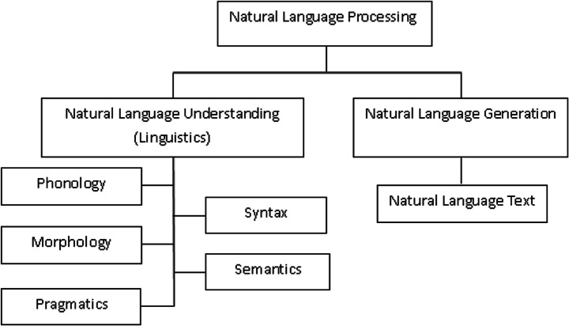Natural Language Processing (NLP) serves as a bridge between human communication and computer understanding serving itself as a base in both Artificial Intelligence and linguistics. Designed to make the interactions between humans and computers easy and more accessible. NLP aims to enable computers with the ability to understand human language with ease thus overcoming the need for people to master complex computer languages. NLP divides into two main branches, Natural Language Understanding and Natural Language Generation, focusing on understanding and the generation of human like text respectively. Linguistics the scientific study of language is crucial to NLP and it includes everything from phonology to semantics.

Figure Showing the Hierarchy of NLP

## History of NLP

The history of NLP can be traced back to the 20th century marked by technological advancements and contributions from different disciplines. This idea of NLP began in the late 1940s period when NLP as a term wasn’t coined yet. The initials steps towards machine understanding of human language were being laid (Hutchins, W.J., 1986). The initial focus was on Machine Translation a task that planned to automatically translate text from one language to another in the beginning the two languages that were chosen were Russian and English. This era was characterized by optimism. The ambitious projects that were planned aimed at breaking down language barriers using computers.

However this development faced a setback when the ALPAC report was released in 1966. Which stated that the future for MT was not so bright and therefore recommended a reduction in funding for such research (Hutchins, W.J., 1995). This report significantly hindered the progress of NLP research leading to a period of re calculation of goals within the field. Despite this roadblock some MT projects continued to operate slowly refining their approaches and continued laying the groundwork for future development of NLP.

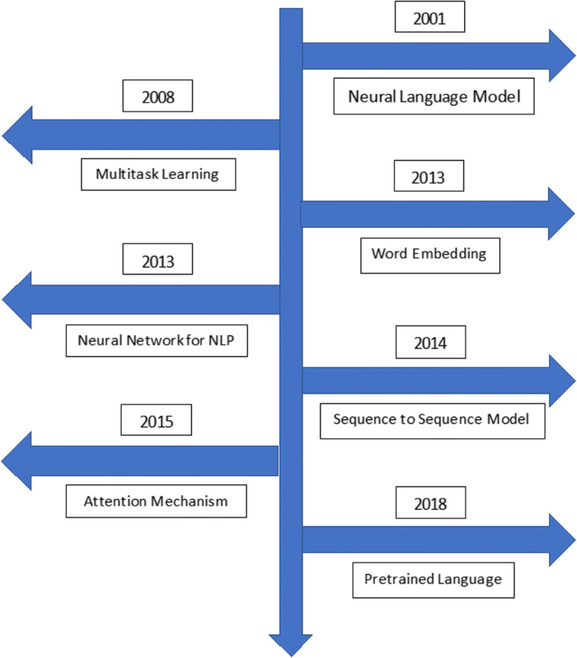

Figure Showing the Development of NLP overtime

Today NLP stands as a dominant and very important field in computer science which stands at the unison of AI, linguistics and computer science. This field of AI is continuously evolving with the introduction of new models and datasets. But the history showcases its journey of overcoming challenges adaptation of new methodologies and expanding the boundaries of what machines can understand and use that understanding to generate meaningful and informative information. The future of NLP promises more applications of it in other applications such as law, customer service etc. It also promotes deeper understanding of linguistics and development of applications that extend beyond current capabilities of NLP.

## Machine learning in NLP

Machine Learning plays a very important role in NLP which have facilitated the advancement in the field which have revolutionized the way machine understand the give text data and generate Reponses based on that. The way it has been possible is by using patterns in data machine learning algorithms enable computers to perform complex NLP tasks without specific programming for each specific task beforehand. This use of ML in NLP has led to the development of applications such as speech recognition software’s, sentiment analysis models, Text Translation models and chatbots which are just some of its applications and more of its applications are still being worked on.

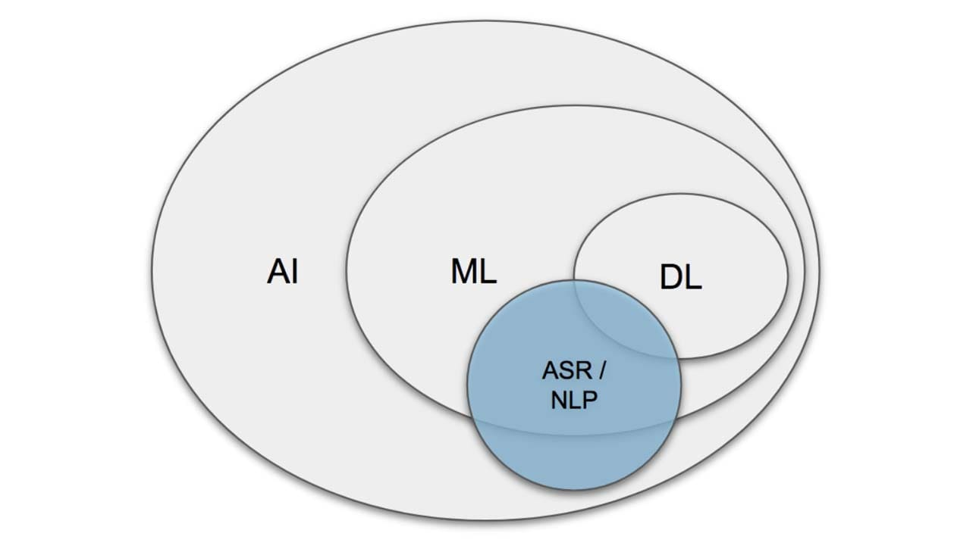

Figure Showing the Overlap of NLP with ML and DL

Machine learning models like Naive Bayes, decision trees and support vector machines to advanced neural networks have provided NLP with the stepping stones to move forward resulting in wide variety of applications. These models are trained on large datasets learning to predict or classify text data.

With the development of transformer models i.e., BERT and GPT. The development of these models showcase a leap forward in the development of NLP. These models have set new standards for a lot of wide range of NLP tasks by capturing deep contextual relationships within text (Vaswani, A. et al., 2017; Devlin, J. et al., 2019). Their ability to pre-train on vast amounts of text data and fine-tune for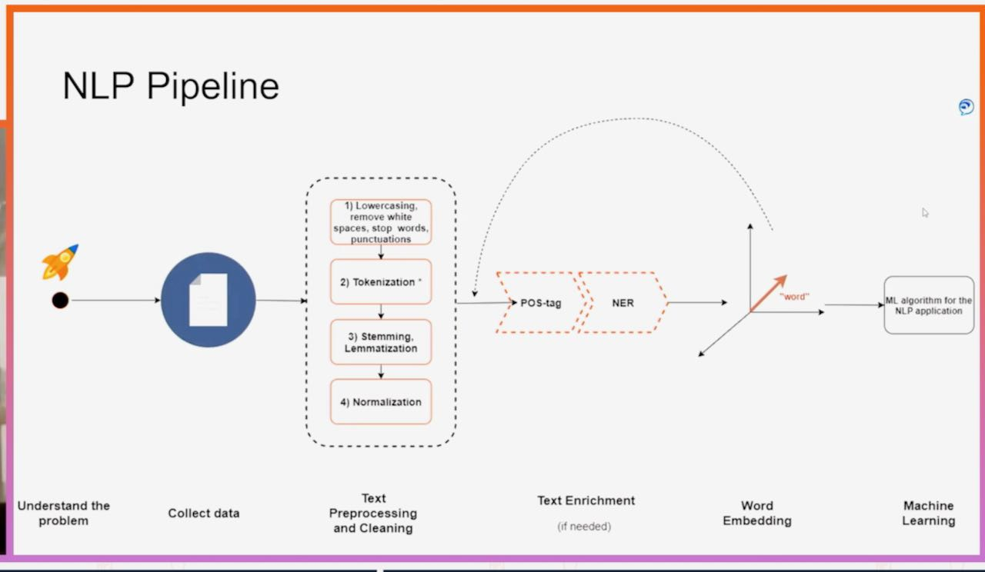 specific NLP tasks has made it more accessible and relatively easy to get accuracy in language understanding and generation of information based on specific NLP tasks.

Figure Showing the NLP Pipeline

Despite significant progress being made in the field integrating machine learning into Natural Language Processing for further development of NLP presents a lot of challenges. Some of the challenges include the need for large datasets with detailed and correct annotations for training which can be resource intensive. Additionally, machine learning models struggle to understand the complexities of human language as they have lot ambiguous/unclear references in the form of sarcasm or something that is said out of the context of the topic. These models also require a lot computational power to train making the development of the models expensive and relatively difficult task to achieve. Furthermore, there is an ongoing effort to make these models more transparent in regards on how they make decisions to reduce biases that may be present in the training data used for training the model. Addressing these issues is very important for developing the NLP technologies further and to make sure the development is fair and understandable.

## The Role of NLP in Enhancing Access to Justice

The role of Natural Language Processing (NLP) in enhancing access to justice is significant by using the power of AI in law we have been able to bridge the gap between the existing legal services and the people who are in need of these services. This is achieved as a result of automating and streamlining the legal process and procedures that exits. With the help of NLP, we have been able to make legal information more accessible, understandable and actionable either by individuals or communities who back in the day wouldn’t have resources for legal representation

**Make the Legal Language simple**

One of the primary problems in accessing justice is the complexity of legal language. NLP tools have enabled us to translate legal terms/jargons into plain language which in return makes legal documents, regulations and procedures more understandable to a common person who doesn’t have any knowledge about the legal terms. The NLP can also make law more accessible by providing summaries of legal texts and also by explaining legal concepts in simple terms. Thus, NLP enables individuals in navigating the legal system more confidently which results in them making more informed decisions about their legal dilemmas (Katz, D.M., Bommarito II, M.J., and Blackman, J., 2017).

**Automated Legal Assistance**

Legal chatbots and virtual assistants which are powered by NLP, offer initial legal advice and assist in document preparation which range from simple contracts to more complex legal filings Thus making the whole process a lot more convenient and easy for individuals. This application would also be explored in the case Litigat8 as well. These types of applications can guide users through legal processes, such as asking the relevant questions according to the problem the user is in and generate documents such as contracts, tenancy agreements based on the user's responses which in fact significantly lowers the barrier to start legal actions or responding to legal issues (Sourdin, T., 2018).

**Enhancing Legal Research**

NLP helps lawyers and legal researchers quickly search through huge amounts of legal documents like court cases and laws. By employing NLP tools, lawyers and researchers can easily find important past cases it can also detect trends in legal decisions and collect evidence for their current cases if they are working on any. This makes their work more efficient which also helps to reduce costs. As a result, people who might not have a lot of money benefit because they can get better legal help that they can afford. (Alarie, B., Niblett, A., and Yoon, A.H., 2018).

**Accessible Dispute Resolution**

There are Online Dispute Resolution (ODR) platforms which utilize NLP to offer accessible means for resolving disputes outside of traditional court settings. These platforms automate parts of the mediation. The ODR platforms can resolve conflicts more quickly and with less financial strain on the parties involved which in results make justice accessible for all even if they are less fortunate (Rule, C., 2017).

## Identifying and Mitigating Bias

### Privacy and Security Concerns in Legal NLP Applications

When it comes to NLP Privacy and security concerns are one of the biggest concerns in the deployment of Natural Language Processing applications within the legal domain. The Legal NLP applications, which handle sensitive and potentially confidential information makes it important to put in place some strict protocols and security measure to protect the user data as it can be confidential and of sensitive nature. The processing of legal documents, client communications between the NLP model and User and other sensitive information which can be possessed by NLP systems raises substantial concerns about data protection, unauthorized access and the potential misuse of information.

One of the primary challenges faced by legal NLP applications is ensuring the confidentiality and integrity of the data processed by it. The used legal documents often contain confidential information, trade secrets and personal data subject to various privacy laws such as the General Data Protection Regulation (GDPR) in Europe (Voigt, P., and Von dem Bussche, A., 2017). Because of these reasons, the NLP systems used in the legal field must incorporate robust encryption methods for data storage and transmission, coupling it with secure access controls to prevent unauthorized access to sensitive information.

Furthermore, the use of NLP in legal applications involves ethical considerations such as the fairness and transparency of automated systems. The Bias in legal NLP models can lead to unfair outcomes or discrimination in the response generated or the legal advice which causes us to undermine the trust in automated legal analysis (Barocas, S., Hardt, M., and Narayanan, A., 2019). Therefore, NLP models generated for legal applications must be designed with fairness in mind and it should me made sure to incorporate methods to detect and mitigate bias in training data and model predictions.

Moving on ,another significant concern of NLP in legal applications is the potential for data breaches and the unauthorized leakage of sensitive information associated either with users or the law firm for instance using that application. It should be made sure that the Legal NLP applications must comply with legal standards for data protection, and they must implement stringent/strict security protocols and they development body should regularly audit systems for vulnerabilities (Romanosky, S., 2016). Moreover, there is a need that we put in place clear guidelines and regulations which should govern the use of AI and NLP in legal contexts ensuring that these technologies are used responsibly and ethically.

In summary, privacy and security concerns in legal NLP applications are critical issues that require careful consideration and proactive measures to prevent them from happening. Protecting sensitive legal information while ensuring the fairness and transparency of NLP systems is essential for maintaining client trust and compliance with legal and ethical standards and thus important for NLP to flourish in this field.

### Current Trends and Future Directions of NLP in law

The integration of Natural Language Processing within the legal domain has been very evolving in the recent years reshaping how legal professionals in practice interact with vast amounts of textual data and how they use it to streamline various aspects of legal research, document analysis and client services. As NLP technologies continue to develop several current trends and future directions of NLP in legal settings are emerging in the field of law which promise to further revolutionize they field of law as we know it right now.

**Current Trends**

**1**. ***Automated Legal Document Analysis:***

One of the applications of legal NLP is to automate the analysis of documents like contracts. The way NLP model helps is by quickly finding and pulling out relevant and important information from these documents. Which can then be analyzed for whatever purpose the legal professionals want to use it for. For example, a legal NLP model can identify key clauses in contracts and can summarize long legal opinions which results in saving time and thus making legal work more efficient. This application of legal NLP not only speeds up the process of reviewing legal documents but also reduces the chance of making mistakes thus resulting in improved accuracy and reliability of legal research or due diligence. This application of NLP has streamlined many routine tasks in legal practices. (Zhong, H., Guo, Z., Tu, C., Xiao, C., Liu, Z., and Sun, M., 2020).

**2**. ***Legal Chatbots and Virtual Assistants:***

One of the other applications of NLP is Legal chatbots and virtual assistants which have NLP capabilities and they are becoming more prevalent and more used in day to day legal needs. These NLP technologies offer basic legal advice to the public helping them navigate through the complexities of the legal world and they also help in drafting simple legal documents and provide support for customer service operations in law firms making legal services more accessible (Kreutzer, R.T., and Sirrenberg, M., 2019).

**Future Directions**

**1. *Enhanced Legal Predictive Analytics:***

The future of NLP in law includes the development of more advanced prediction and analytics tools. The way this system would work is by analyzing historical legal data and then the NLP models would be able to predict the outcomes of cases like what would be the decision based on the precedent set by the cases related to the case that is being analyzed this would help lawyers make better informed decisions about case strategies and thus would increase the chances of success (Ashley, K.D., 2017).

**2.** ***Ethical Use of NLP in Legal Applications:***

As NLP technologies become more common in legal practice, there will be an increased focus on ensuring the ethical and safe use of these tools. This will include addressing concerns related to unbalanced/bias outcomes and transparency of NLP models to ensure fair and impartial legal outcomes (Branting, L.K., 2021). To solve these problems work is being done to develop methods to test and correct biases in algorithms along with designing systems that can explain their own decisions and can follow strict guidelines to uphold ethical standards in their applications.

**3. *Cross-lingual and Multijurisdictional Legal NLP Applications:***

Another possible application of Future NLP systems will likely become more adept at handling multiple languages and legal jurisdictions which would facilitate in cross-border legal research and global compliance tasks in different countries instead it being locked up by the knowledge of just single country. This advancement could come in really handy for international law firms and organizations dealing with cases which fall in under lots of jurisdictions legal issues (Tsarapatsanis, D., and Aletras, N., 2021).

## Market Analysis

### The Existing Market of household and Tenant law

When we consider the practical applications of NLP in legal systems, certain domains can benefit significantly, such as Property Law or Household and Tenant Law. These areas are particularly relevant given the market size and the number of active individuals who, at some point in their lives, must deal with the legal jargon of property law. According to Nimblefins, there are almost 8.5 million households currently renting in the UK property market. To put this into perspective, that number represents households, not individuals; thus, the actual count of people involved in this market is far greater. These figures include just tenants; there are also millions of landlords who must address the needs and problems of every tenant. Due to a lack of legal knowledge about this particular domain of law, many tenants face significant trouble dealing with courts and lawyers, which can be economically intensive for both parties simply because they lack basic guidance on how to navigate these issues, such as whether they even need a lawyer. According to ITV, there were almost 30,230 no-fault evictions in the UK as of 2023, which could have been easily avoided if the tenants and households had sought guidance earlier rather than getting into legal trouble by turning to lawyers when it was too late. Likewise, for landlords, just in the city of Sheffield, the disrepair cases rose from 117 in April 2018 to over 1,750 cases, where the landlords had to pay the tenants, compensation totaling around 3 million pounds. Hence, there exists a gap that needs to be filled to make people more accessible to the knowledge of household and tenant law.

### Existing Solutions for Household and Tenant Law

When it comes to existing solutions for household and tenant law in the NLP domain, search queries like "household and tenant law chat app," "NLP app in household and tenant law," and vice versa were used, but there wasn’t a solution that existed in this domain. However, I found many use cases and examples of NLP in law. For instance, Nessa, an LLM solution developed by OLS Solicitors, was recognized as it did the job of providing basic advice regarding matters of family law. The solution that was developed was based on the GPT-4 model. Even though it provided basic advice, it wasn’t able to generate case law references for the advice given, even when specifically asked for it, and this was a gap I feel could be filled with the help of Litigate, making sure it provides case law references to the user if prompted too.

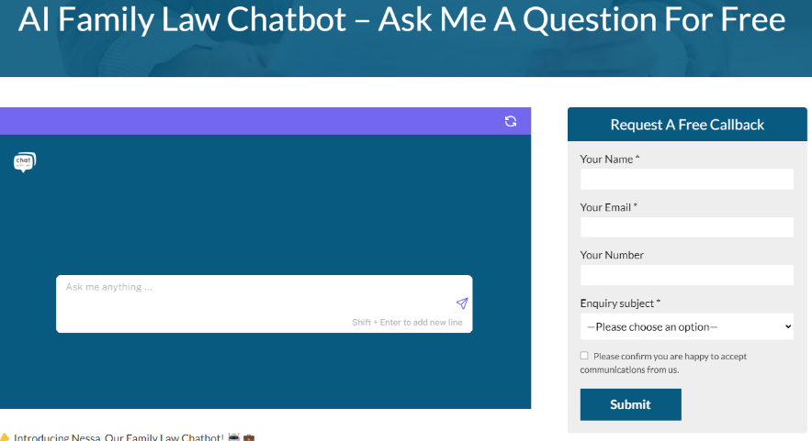

Figure Showing the Nessa App Interface

The Nessa app didn’t have the ability to save or store your chat session, which I feel makes it look a little less personalized and maybe even not that attractive to the user.

Following the analysis of Nessa another innovative solution was analyzed as well and which as AI Lawyer, which was more focused on the domain of law research and had tones of innovative features like ability to draft documents and upload document to question the NLP model for. The UI was very innovative and can serve as an inspiration for the development of Litigate but because of it being a paid service a proper analysis of the platform couldn’t be carried out.

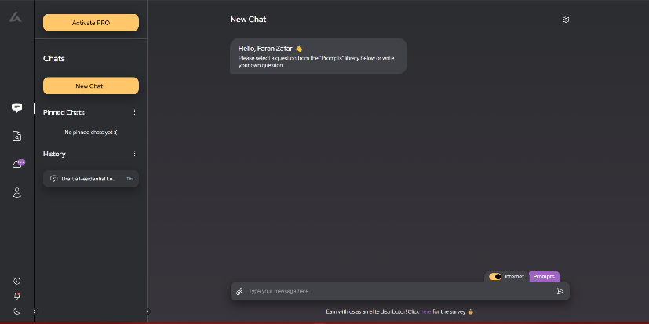

Figure Showing AI Lawyer interface

A feature that it was lacking was legal advice generation and case law reference based on the specific advice. This again leaves a gap for this proposed solution to solve, which would be discussed in the next chapter of this report.

# Project Proposal

## Project Details:

Litigate would be an online, hosted chat application accessible as a web application. Users can find legal advice related to household and tenant law on the go. There will be a no age limit for accessing the platform, people from all backgrounds will be able to use the application. An NLP model working in the backend in relation to a database, will process user queries in real-time and produce appropriate responses using NLP techniques. The responses will include basic advice about the matter and, if available, a case law relevant to the issue from the database would be produced.

## Project Specification/Objectives:

**Project Scope and Objectives:**

The scope of the project has been defined by the identified said objectives that need to be accomplished throughout the development of the project. The primary objectives carry more weight as they would be allocated the most resources and time before the presentation of the project in April,2024. If the primary objectives are achieved only then the secondary objectives would be considered implementing into the overall workflow of the application.

**Primary Objectives:**

1. ***User Interface Development:*** Design a user-friendly interface desktop platform that allows users to easily interact with the chat application.
2. ***Natural Language Processing Integration:*** Implement a robust NLP model to understand and process user queries accurately in real-time.
3. ***Legal Database Creation:*** Compile a database that includes relevant case laws, statutes, and legal precedents in the form of documents pertaining to household and tenant law.
4. ***Real-time Response Generation:*** Develop a system capable of generating accurate legal advice and relevant case law references in response to user queries.

**Secondary Objectives:**

1. ***Accessibility and Inclusivity*:** Ensure the app is accessible to users from all backgrounds, with considerations for those with disabilities
2. ***Security and Privacy:*** Implement robust security measures to protect user data and ensure privacy especially when handling sensitive legal queries.
3. ***User Authentication:*** Create a secure user authentication system requirement for accessing the platform.
4. ***Feedback Mechanism:*** Incorporate a feedback mechanism to collect user responses on the accuracy and helpfulness of the legal advice provided facilitating continuous improvement.

## Project Functional and Non-Functional Requirements

**Functional Requirements:**

| ID | System Component | Requirement Description |
| --- | --- | --- |
| FR1.1 | User Account Management | The system shall allow users to register |
| FR1.2 | User Account Management | The system shall implement a secure login mechanism with password authentication. |
| FR1.3 | User Account Management | The system shall provide a secure logout function |
| FR1.4 | User Account Management | The system shall manage user sessions |
| FR2.1 | NLP Integration | The system will integrate a Natural Language Processing engine |
| FR2.2 | NLP Integration | The system shall use the NLP engine to interpret and understand the context of legal queries. |
| FR3.1 | Legal Database Management | The system shall compile and store a database of legal documents |
| FR3.2 | Legal Database Management | The system shall provide search functionality to retrieve legal information from the database. |
| FR4.1 | Real-time Response | The system shall generate responses to user queries by extracting relevant information |
| FR4.2 | Real-time Response | The system shall display the generated legal advice and case law references |

Table Showing Functional Requirements of Litigat8

**Non-Functional Requirements:**

| **ID** | **Category** | **Requirement Description** |
| --- | --- | --- |
| NFR1.1 | Feedback and Improvement | The system shall provide a mechanism for users to give feedback |
| NFR1.2 | Feedback and Improvement | The system shall use user feedback to improve the accuracy. |
| NFR2.1 | Performance and Scalability | The system shall be scalable to accommodate additional functionalities |
| NFR3.1 | Security and Privacy | User data shall be encrypted in transit and at rest |
| NFR3.2 | Security and Privacy | The system shall ensure privacy of user queries and responses |
| NFR4.1 | Usability | The user interface shall be intuitive and easy to navigate |
| NFR4.2 | Usability | The system shall provide clear and understandable responses to user queries. |
| NFR5.1 | Reliability | The system shall have an uptime of 99.9% |
| NFR5.2 | Reliability | The system shall provide consistent and accurate legal advice |
| NFR6.1 | Accessibility Compliance | The system shall include features that make it accessible to users with disabilities |
| NFR7.1 | Chat Session Management | The users shall be able to create new chat sessions |
| NFR7.2 | Chat Session Management | The users shall be able to review their previous chat sessions |

Table Showing Non Functional Requirements of Litigat8

## Project User Stories

Keeping the Objectives and the idea of the project in mind. I brainstormed the potential use cases a user can have with the application. Which would further be broken down using other analysis techniques such as MoSCoW depending on the resources and time available. Following are the potential use cases of a user with the application:

**Use Case 1:** User Registration

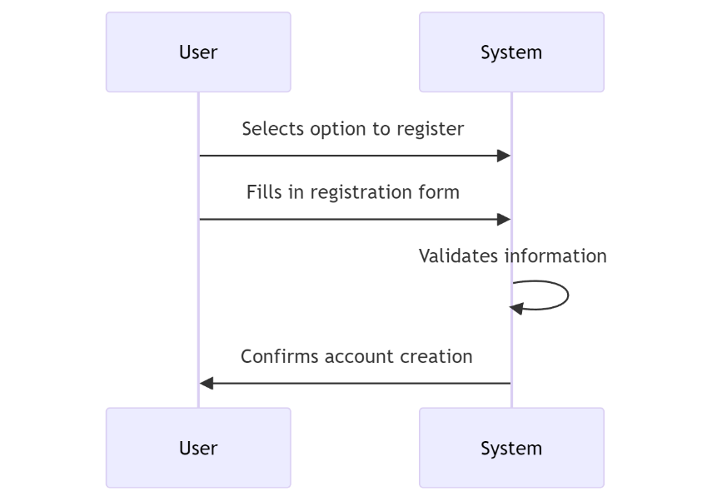

Figure Showing User Registration Use Case

**Use Case 2:** User Login

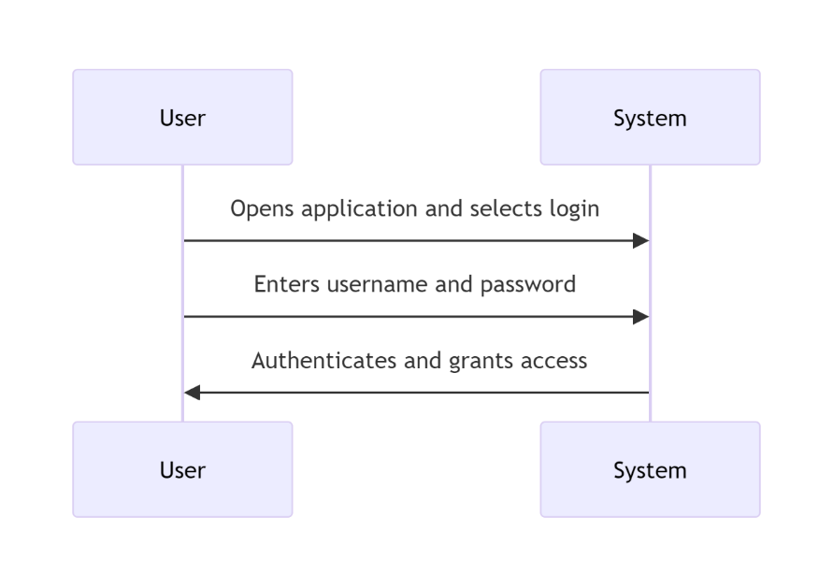

Figure Showing User Login Use Case

**Use Case 3:** User Receives Legal Advice

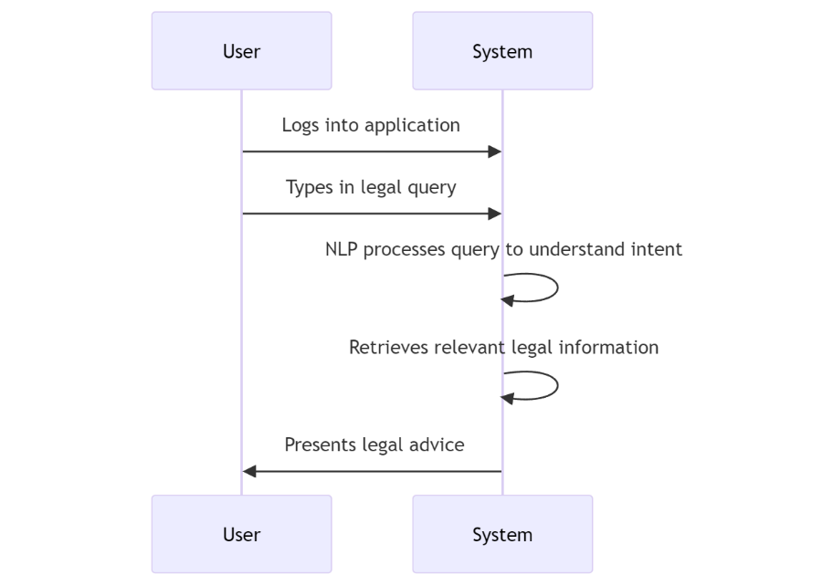

Figure Showing User Legal Advice Use Case

**Use Case 4:** User Reviews Chat History

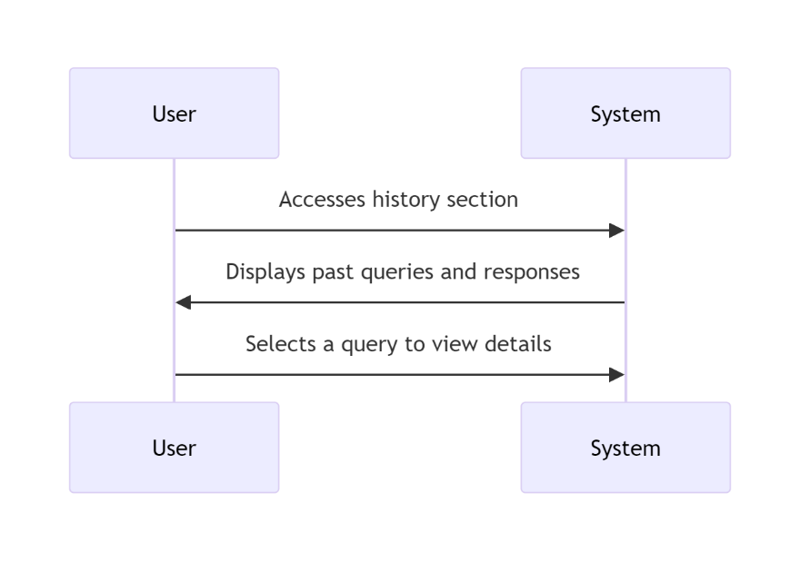

Figure Showing User Chat History Review Use Case

**Use Case 5:** User Provides Feedback

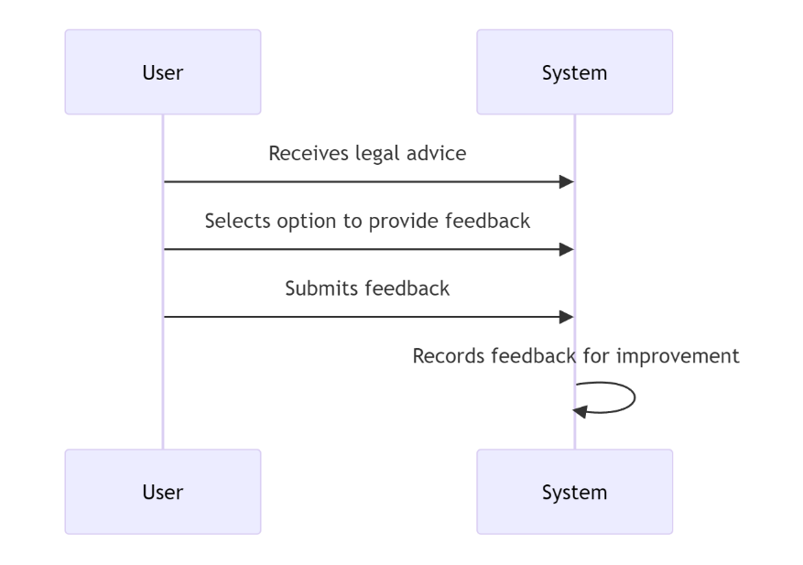

Figure Showing User Providing Feedback Use Case

**Use Case 6:** User Logs Out

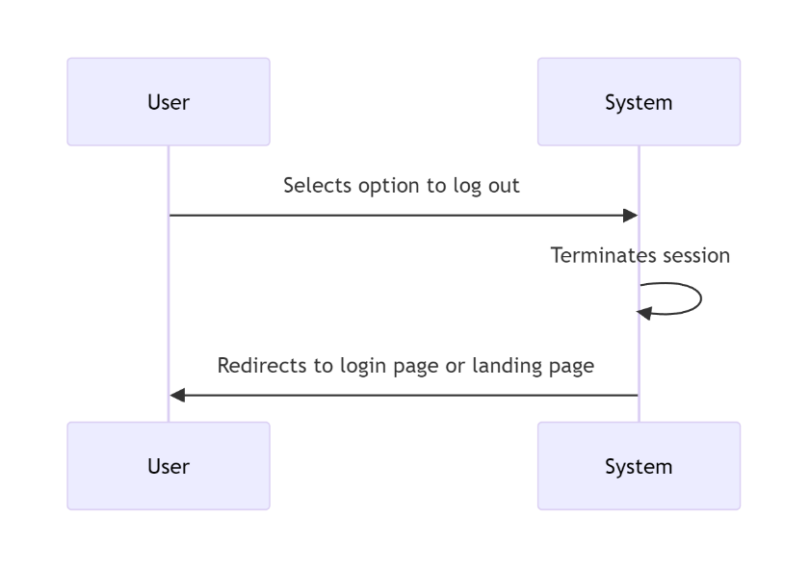

Figure Showing User Logout Use Case

## High Level System Design:

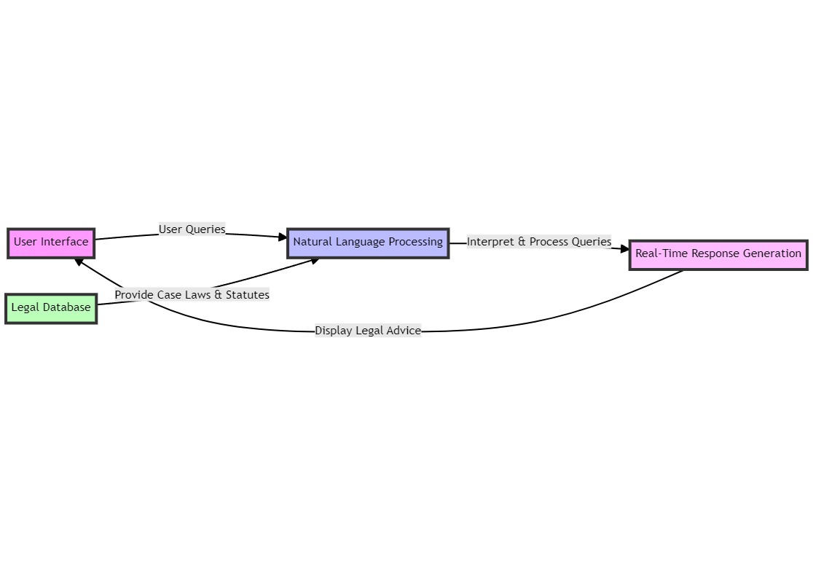In line with the user stories I've decided to focus on, sketching out a high-level design (HLD) helps us map out the system's architecture in a nutshell. This overview helps pinpoint the necessary hardware and software interactions, data exchanges, and communication flows across the system. At the heart of the architecture is a user interface designed to retrieve and update information from database tables. One of the key advantages of our approach is its scalability. As new data needs arise in the future, our system can easily expand to accommodate these additional data sources.

Figure Showing General Overview of the Application

This diagram shows a high-level flow of data between different software and hardware components.

Figure Showing HLD Design of Litigat8

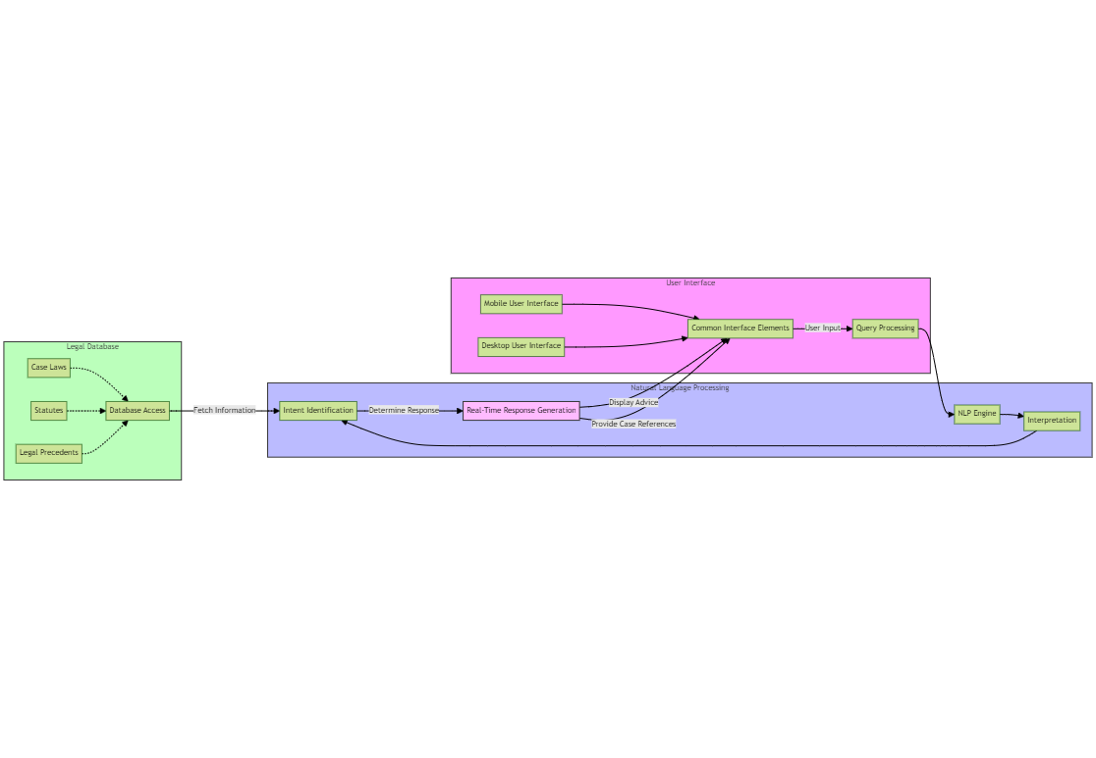

One of the disadvantages of using the architectural design and solution, is the current technological skillset that is needed to achieve this implementation of the project. The Mitigation of the potential risks will be taken into account by discussing the it with the supervisor every week.

The diagram presented offers a detailed view of our proposed high-level design, showcasing the different elements, connections, and data movements.

# Requirement Analysis:

The requirements would be defined using the MoSCoW Analysis and according to the objectives defined before.

## MoSCoW Analysis

Based on the objectives mentioned in the Project Scope and objective I was able to shortlist the requirements for the project using the Moscow Method. Where the Must have requirements take the highest priority followed by should have and could have requirements respectively. And I thought of the requirements that could be implemented as a part of future development of the project

| **ID** | **Requirement ID** | **Category** | **Requirement Description** | **MoSCoW** |
| --- | --- | --- | --- | --- |
| M1 | FR1.1 | User Account Management | The system shall allow users to register | Must Have |
| M2 | FR1.2 | User Account Management | The system shall implement a secure login mechanism | Must Have |
| M3 | FR1.3 | User Account Management | The system shall provide a secure logout function. | Must Have |
| M4 | FR1.4 | User Account Management | The system shall manage user sessions. | Must Have |
| M5 | FR2.1 | NLP Integration | The system will integrate a Natural Language Processing engine. | Must Have |
| M6 | FR2.2 | NLP Integration | The system shall use the NLP engine | Must Have |
| M7 | FR3.1 | Legal Database Management | The system shall compile and store a database of legal documents. | Must Have |
| M8 | FR3.2 | Legal Database Management | The system shall provide search functionality to retrieve legal information | Must Have |
| M9 | FR4.1 | Real-time Response | The system shall generate responses to user queries | Must Have |
| M10 | FR4.2 | Real-time Response | The system shall display the generated reponse | Must Have |
| M11 | NFR3.1 | Security and Privacy | User data shall be encrypted in transit and at rest. | Must Have |
| M12 | NFR3.2 | Security and Privacy | The system shall ensure privacy of user queries and responses. | Must Have |
| M13 | NFR5.1 | Reliability | The system shall have an uptime of 99.9%. | Must Have |
| S1 | NFR1.1 | Feedback and Improvement | The system shall provide a feedback mechanism | Should Have |
| S2 | NFR1.2 | Feedback and Improvement | The system shall use user feedback to improve the accuracy. | Should Have |
| S3 | NFR7.1 | Chat Session Management | The users shall be able to create new chat sessions. | Should Have |
| S4 | NFR7.2 | Chat Session Management | The users shall be able to review their previous chat sessions. | Should Have |
| C1 | NFR4.1 | Usability | The user interface shall be intuitive | Could Have |
| C2 | NFR4.2 | Usability | The system shall provide clear and understandable responses | Could Have |
| C3 | NFR2.1 | Performance and Scalability | The system shall be scalable | Could Have |
| W1 | NFR6.1 | Accessibility Compliance | The system shall include features that make it accessible to users with disabilities. | Won't Have |

Table MoSCoW analays of Litigat8

## Project System Requirement:

Based on the requirement analysis done for the project. I have decided on the software and hardware requirements of the project. As the requirements of the project are modest and it would only be hosted on the localhost for the MVP. I have kept the requirements at minimum for the functioning of the project.

**Development Languages and Tools**:

1. ***Backend Programming Language:*** Python chosen for its extensive library support, particularly for natural language processing (NLP) tasks. I decided to choose this language for the access of the existing information for python in compared to other languages such as C++. And another factor that contributed to its selection was my own proficiency in the language given the duration of the project. It would have been very highly unlikely to complete the project if I had decided to proceed with the language, I didn’t have command on.
2. ***Frontend Web Technologies:*** HTML, CSS, and JavaScript, for creating an interactive and user-friendly web interface. The User interface is decided to kept simple as most of the resources and time would be allocated to developing the NLP model. Hence, no frontend framework is being used at the moment but if time is left. I’m planning to implement React as the frontend framework for the application.
3. ***NLP Library:*** NLTK, utilized for implementing the chat application's NLP capabilities to process and understand user queries. From the NLTK libraries, I’m going to be using PortStemmer , stopwords, word_tokensise to implement functions such as tokenization, stemming and bag of words.. For developing and making the vector database for the project I would be using libraries such as Pincone and Chroma. While for the rest of the functionality of the NLP model I would be using LangChain which in itself has many libraries such as OpenAI, Ctransformers which would be used and detailed in the implementation section
4. ***Web Framework:*** Flask, selected for its simplicity and efficiency in setting up lightweight web applications, suitable for a project focused on functionality demonstration. Option of Django was considered as well for the development of the project but given the simple nature of the MVP I decided to settle down for flask. And I had some previous experience using this framework so it was a natural choice for me.
5. ***Database System:*** MySQL is used due to its ease of integration with Python applications and sufficiency for the storage needs of a development-stage project.
6. **Integrated Development Environment(IDE):** VsCode will be used for its support for Python and web technologies alongside it conda would be use to set up a virtual environment. Github, would also be implemented for version control of the project.

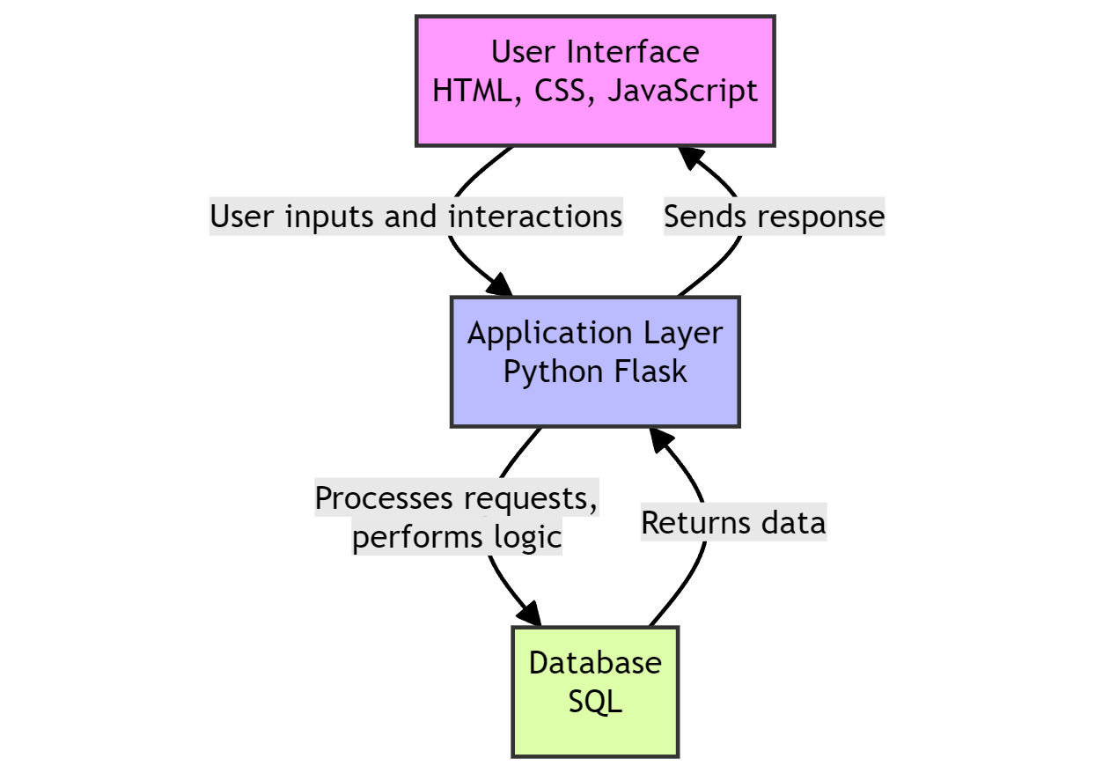

Figure Showing Different Layers of Litigat8

**Hardware Requirements:**

Given the localized hosting and demonstration focus of the project, the hardware requirements are kept simple:

1. ***Processor***: A minimum of a Dual-core processor is required to ensure smooth running of the development server and NLP processes.
2. ***Memory:*** At least 4 GB RAM to support the simultaneous execution of the development environment, web server etc.
3. ***Storage:*** A minimum of 5 GB of available disk space to accommodate the application codebase, MySQL database, and Vector Database and other dependencies.

## Traceability Matrix:

After carrying out in depth analysis of the requirements of the application and potential use cases, a traceability matrix was designed to ensure that the objectives put in place are fully achieved by meeting the defined use cases along with the MoSCoW requirements for Litigat8 .

| **Requirement ID** | **Requirement Description** | **Linked Use Case** | **Supported Primary Objective** | **Supported Secondary Objective** |
| --- | --- | --- | --- | --- |
| **FR1.1** | User registration | Use Case 1 | P1 | S3 |
| **FR1.2** | Secure login mechanism | Use Case 2 | P2 | S3 |
| **FR1.3** | Secure logout function | Use Case 6 | P2 | S2 |
| **FR1.4** | Manage user sessions | Use Case 6 | P2 | S |
| **FR2.1** | Integrate NLP engine | Use Case 3 | P2. |  |
| **FR2.2** | Use NLP engine | Use Case 3 | P2 |  |
| **FR3.1** | Compile legal database | Use Case 3 | P3 |  |
| **FR3.2** | Search legal information | Use Case 3 | P4 |  |
| **FR4.1** | Generate legal advice | Use Case 3 | P4 |  |
| **FR4.2** | Display legal response | Use Case 3 | P4 |  |
| **NFR3.1** | Encrypt user data | All Use Cases | P2 | S2 |
| **NFR3.2** | Ensure privacy | All Use Cases | P2 | S2 |
| **NFR5.1** | System uptime 99.9% | All Use Cases | P4. |  |
| **NFR1.1** | Feedback mechanism | Use Case 5 | P4 | S4 |
| **NFR1.2** | Use feedback | Use Case 5 | P4 | S4 |
| **NFR7.1** | Create chat sessions | Use Case 4 | P1 |  |
| **NFR7.2** | Review chat history | Use Case 4 | P1 |  |
| **NFR4.1** | Intuitive User Interface | All Use Cases | P1 | S1 |
| **NFR4.2** | Clear responses | Use Case 3 | P4 |  |
| **NFR2.1** | System scalability | All Use Cases | P3 |  |
| **NFR6.1** | Accessibility features | All Use Cases | P1. | S1 |

Table Showing Traceability Matrix

# Project Solution

## Assumptions, Constraints, Risks:

**Assumptions:**

***Technical Capabilities:***

It's assumed that the chosen technologies and frameworks for NLP(NLTK, LangChain, OpenAI, HuggingFace), database generation (Chroma), and other functionalities will effectively support the development of Litigat8.As this is a realm still to be explored and considering the limited time and resources available full-scale deployment of the project can be somewhat troublesome. But the given requirements for a Minimum Viable Product (MVP). It is assumed that all the technical requirements are satisfactory.

***Data Availability:***

Adequate and accurate tenant-landlord law documents, statutes, and regulations are available for populating the database. A I’m going to be preparing the dataset myself. It is assumed that the dataset would have adequate information for the model to produce appropriate responses for the user. And all the information would contain in the dataset is correct. Even though there can be discrepancies in the dataset

***User Feedback:***

Users will provide feedback for system enhancement and that the feedback will be constructive. It is assumed that the feedback provided is constructive and explainable but still there can be instances where the feedback isn’t constructive or comprehensible. And User Feedback is one of the secondary objectives hence it would take less resources during the production of software.

***Compliance and Legal Clearance:***

All necessary legal clearances and compliance requirements related to providing legal advice and handling user data will be obtained. It is assumed that the model has been approved of giving legal advices in the matters of household and tenant law. As law and AI is a very tricky domain where you have to be careful about the data that is produced and dispersed to the user. As this is a demonstration of its capabilities and the project is being made for **ONL**Y this purpose. Hence, it is assumed it has all the legal clearance.

***Budget and Time:***

The project will be completed within the allocated budget and time frame. According to the defined user stories and analysis of requirements using methods like MoSCoW. It is assumed that all the set requirements would be completed within Budget and Time. But as this can vary depending on various factors. But for the sake of convivence an assumption is put into place.

**Constraints:**

***Single Stakeholder:***

As the sole stakeholder, your availability and decision-making will be critical for the project's progress and direction. As I’m going to be the only one that would be directing the progress of the project along with the supervisor which can put a bit of constraint on the project in a sense that I would have to make all the critical decision instead of having a shared responsibility of the decision-making progress.

***Budget Limitations:***

Budget constraints may limit the scope of development, particularly concerning the scalability and future plans for web and mobile interface accessibility. The options of cloud hosting and own professional domain will be looked in the future if there are enough resources allocated to the project if there are investors involved in the project but for this development cycle it is constraint to be hosted locally without a domain.

***Technological Limitations:***

The performance of Litigat8 may be constrained by the capabilities of the chosen technologies. Some of the technologies chosen for the project for instance python in itself may not be the best choice when it comes to making heavy load models. But for the sake of demonstration and to have an MVP to show for by the end of April. Some of the technologies were given more weight.

***Geographical and Jurisdictional Limitations:***

Legal advice and statutes provided will be limited to specific geographical regions or jurisdictions. As this model is being developed just for the jurisdiction of UK law hence it would only be able to provide support and advice for Tenant and Household law in UK.

**Risks:**

Some of the foreseeable risks have been identified that could potentially happen in the duration of the project. The mitigation techniques for these risks would be discussed with the supervisor in the weekly meetings. And sufficient alternative pathways would be setup for the project if I encounter any unforeseen circumstances which could lead to failure of any component of the project.

***Technology Failure:***

Risks of technology failure impacting the accuracy and reliability of legal advice provided. As there are going to be lots of functioning elements in the project from the interface to the database lots of different factors would be involved. Hence, there is a risk of technological failure if one of the components crashes or fails due to unforeseen circumstances. But sufficient steps would be taken in order to prevent that from happening. Ensuring good coding practices and proper documentation of the project to ensure any unforeseen circumstances should be delt with using proper protocols put in place.

***Dependency on External Systems:***

Future dependency on external cloud hosting platforms and cloud-based database like firebase and Pincone. I have yet to decide if I want to go for an inbuild database like Chroma and Firebase. Which would be talked about in the meeting with the supervisor which would be safer approach If its decided on settling for cloud-based databases then there is a potential risk that the application might not work because of being depended on an external firebase database. But steps would be taken and would be discussed with the supervisor to mitigate the risk as much as possible.

## Solution Description:

Based on the extensive information that was collected during the research and the requirement analysis of the project, sufficient evidence is provided for the case that a web application would be suffice to resolve the said user stories , objectives and requirements that have been identified for the project. A web application would enable to design a proper interface for the user for ease of access along with a functioning backend layer with an NLP model which in itself is very intensive which would also include a vector database for Retrieval Q/A chain and alongside that would the database for the whole system which would allow to create, update and delete user data along with the chat data. However, due to number of limitations, it is limited in its ability to create complete system. Therefore, the proposed system would deliver a proof of concept, which would only show the potential of the system in case if it’s implemented as a complete system.

The poof-of-concept application (litigat8) will showcase the process to input the query as a string and then the system would be able to process the information to come with appropriate responses along with case laws and statues if they exist for that specific case

The application would showcase how the user would be able to go back to his/her queries if he or she wants to look over his/her queries again.

# Project Management Approach:

## Agile Methodology

In line with modern software development practices the project adopted the Agile methodology starting from October 15 with a projected end date of April 15. This approach is characterized by its flexibility and iterative nature it emphasizes adaptability to evolving requirements as in the case of Litigat8. Agile methodology as it is defined by Beck et al. (2001) offers a dynamic alternative to the rigid linear progression of the Waterfall model. It flourishes in an environments like the one that is needed for litigat8 where user needs and system functionalities may not be fully understood from the start of the project.

## Project Management Using Scrum Framework

Scrum a subset of Agile is chosen as the operational framework for its fit with the project’s objectives. It provided a structured yet adaptable environment to create a user-centered platform. The Scrum methodology facilitated constant supervisor engagement enabling me to incorporate feedback iteratively and ensure that the platform remains aligned with the project objectives.

Weekly sprints were scheduled, wherein I focused on delivering specific, prioritized features from the product backlog. Regular sprint reviews and retrospectives ensured that the project adapted to feedback and improved upon the processes continuously.

## Scrum Sprints

After analyzing the total time left for the project to be completed and the list of features and tasks that need to be carried out during the project development, five sprints in total were deemed sufficient for the development of Litigate. The first two sprints were a week long, and the last three were two weeks long.

At the beginning of each sprint, a sprint planning session was held, ranging from one to two hours. This session identified the problems that are of the highest priority and it ensured that a good amount of time is provided to them as they are essential for the success of the project. It is of utmost importance that the issues that originate are kept on track. For this purpose sticky notes and Trello board will be used on windows. The features will be split into three sections: Done, Doing, and Will Do.

Sticky notes and Trello Board were preferred for Scrum because they are easy to use and accessible. Sticky notes served as a quick source of information for me when working on the development device but Trello board served as version control to make sure the same sprint was being developed across all devices. i.e. Laptop and My PC

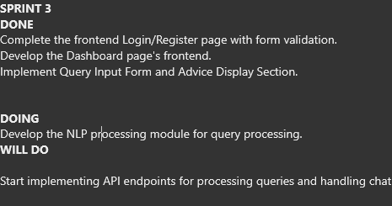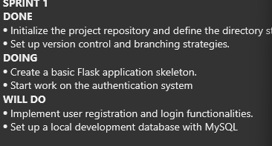

Figure Sample Showing Sprints

Regular meetings were held with the supervisor to ensure that the development is going according to plan and is not deviating from the set objectives.

With new features being added, complete testing of the features was carried out using debug statements as well as unit testing and integration testing, thus making sure all potential discrepancies and risks were captured.

At the end of each sprint, a review was also be conducted to estimate the tasks to be done and the tasks that have been completed, to ensure that no tasks are left uncompleted before moving to the next sprint.

## Project Management Tools

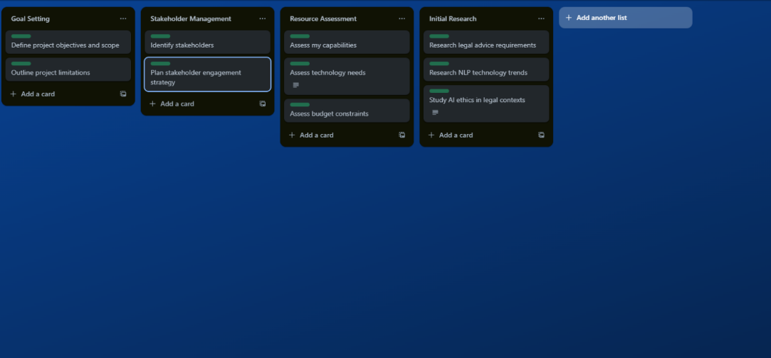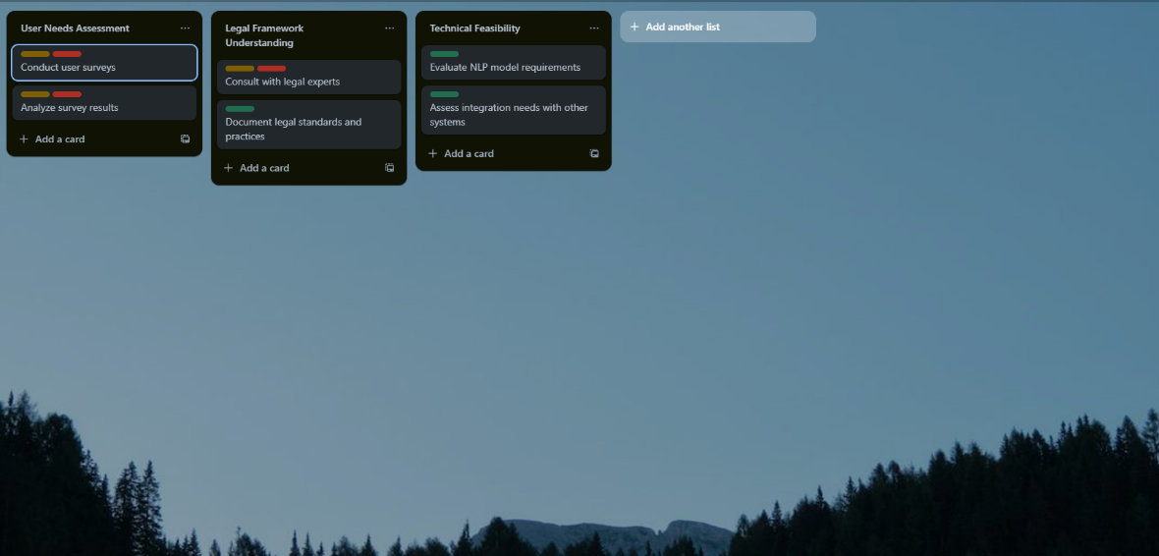Trello was instrumental in organizing the workflow. It enabled the categorization of tasks into boards representing different Scrum artifacts along with that it also helped in time management. Trello's visual interface and ease of reorganization along with the dynamic nature of Agile project management did the job of providing transparency and a high-level overview of the project's status at any given time.

Figure Showing Trello Board for litigat8- 2

Figure Showing Trello Board for litigat8- 1

**Gantt Chart**

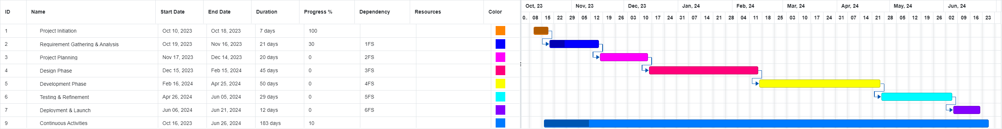Despite Agile's emphasis on flexibility, the project's timeline was charted

Figure Showing Project Timline Managment Using Gantt Chart for Litigat8 -1

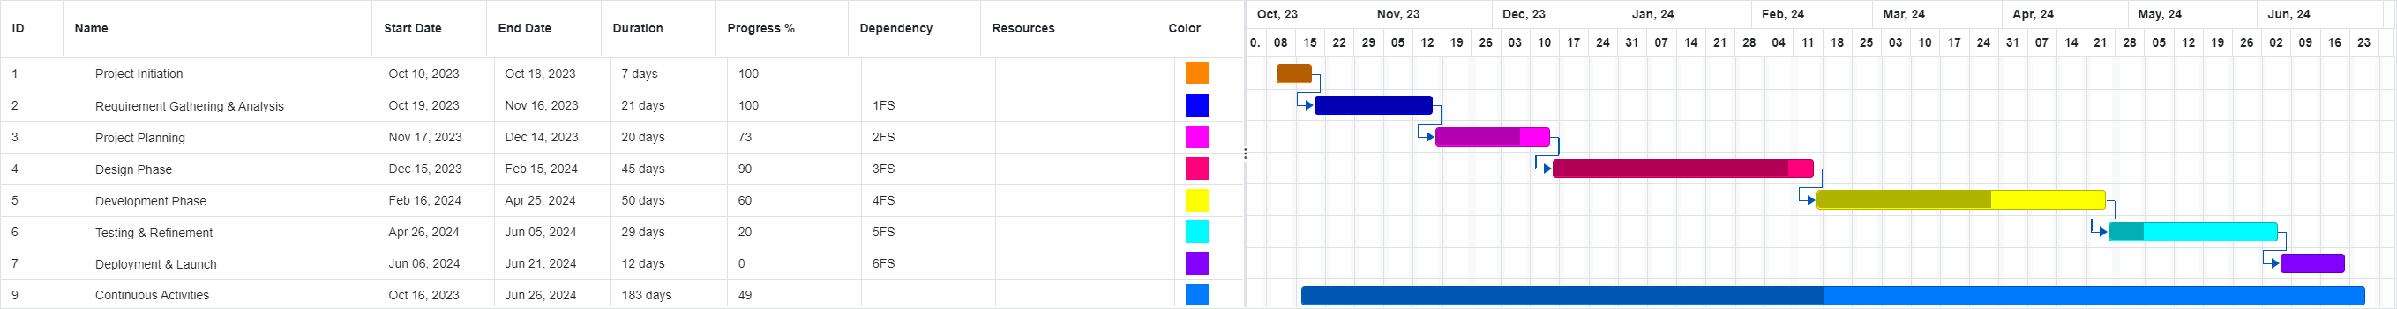

Figure Showing Project Timeline Management Using Gantt Chart for Litigat8 -2

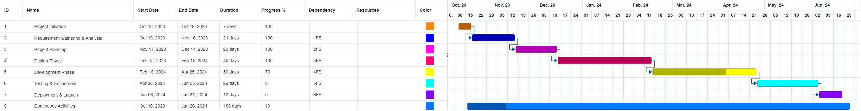

Figure Showing Project Timeline Management Using Gantt Chart for Litigat8 - 3

out using a Gantt chart. This served as a visual planning tool to set key milestones and task durations. It offered a grand view of the project's lifecycle ensuring adherence to the broad deadline and it facilitated the management of dependencies between tasks.

**Version Control with GitHub**

GitHub was selected for version control considering its a robust platform for collaborative coding and it being preferred by most of the developers in the software development community. GitHub’s branching mechanism allowed for the isolated development of features while making sure the integration into the main codebase of each developmental increment after thorough review and testing. This practice not only ensured the integrity and continuity of the development but also encouraged experimental development without risking the system.

The project’s GitHub repository acted as a single source of maintaining a controlled environment for the development for the project where each modification was tracked an if there is any problem the changes were thoroughly analyzed and the problems were eliminated following the analysis

# Design Phase:

This stage marks the design phase of the application where I would be designing the required systems that would be operating within the

## Wireframes:

Wireframes were used to form a design the front-end for the application keeping in mind accessibility and functionality. A great consideration was taken to keep in my mind the requirements as well for the system so that it performs as such as it is planned. The wireframes were designed in **Figma** using the tools provided by the application. The aim was to make the fron-end as intuitive as much as possible so the users don’t have any problem navigating through the application.

**Registration:**

The registration page was designed to accomplish the first objective of having a user authentication system. The frontend was kept as simple as possible with three input placeholders for name/username, email and password. This design would help the users with the ease of registration.

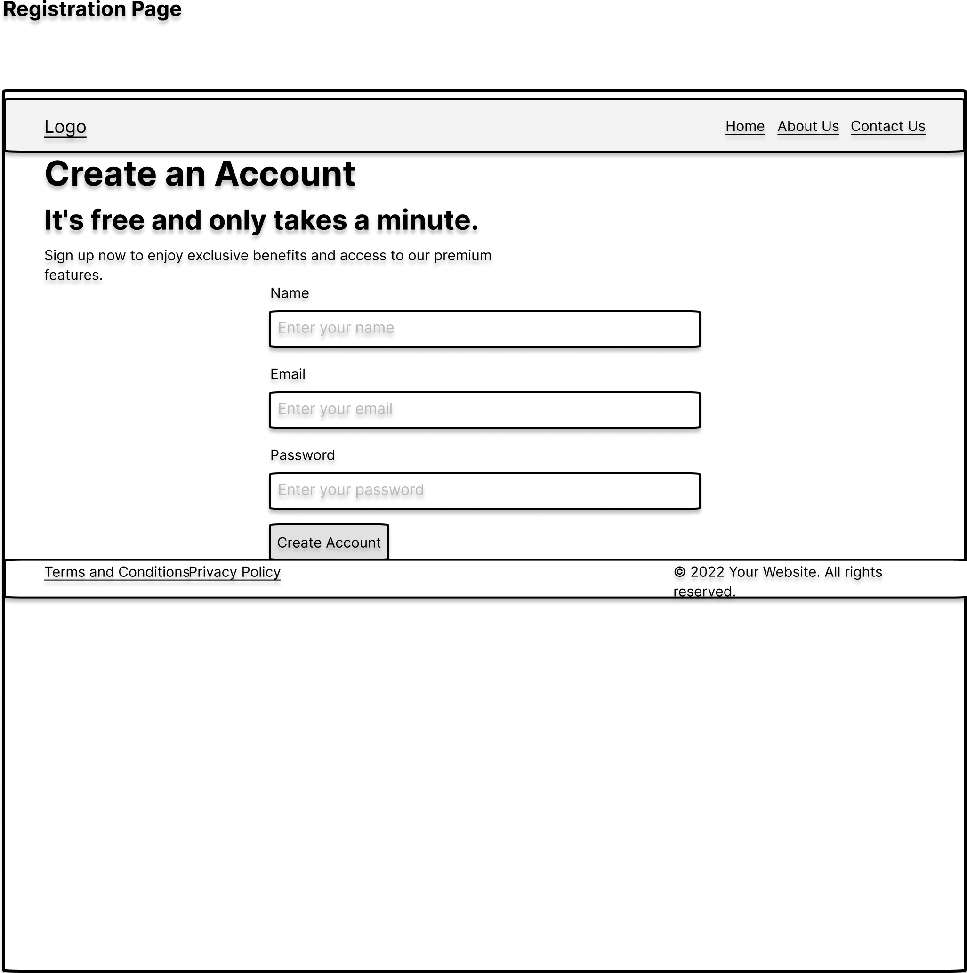

Figure Showing Registration Wireframe

**Login:**

Extending on the authentication system keeping the same objective in mind to keep it simple. The front-end was designed with two input placeholders for email/username and password. Thus making the logging in process as simple as possible for the User.

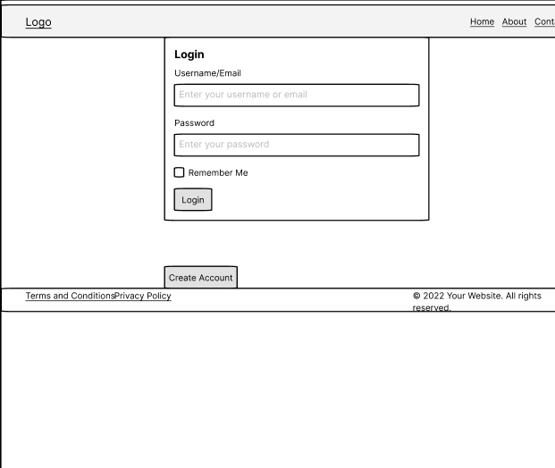

Figure Showing Login Wireframe

**Chat Main Page:**

The main page was designed following the same intuition of accessibility and functionality. The design was kept simple with the input prompt at the bottom and a simple send button to send queries to the NLP model to be processed at the backend. On the Left side is the chat history if the user wants to refer to it at anytime in the future or to go back to reflect on it.

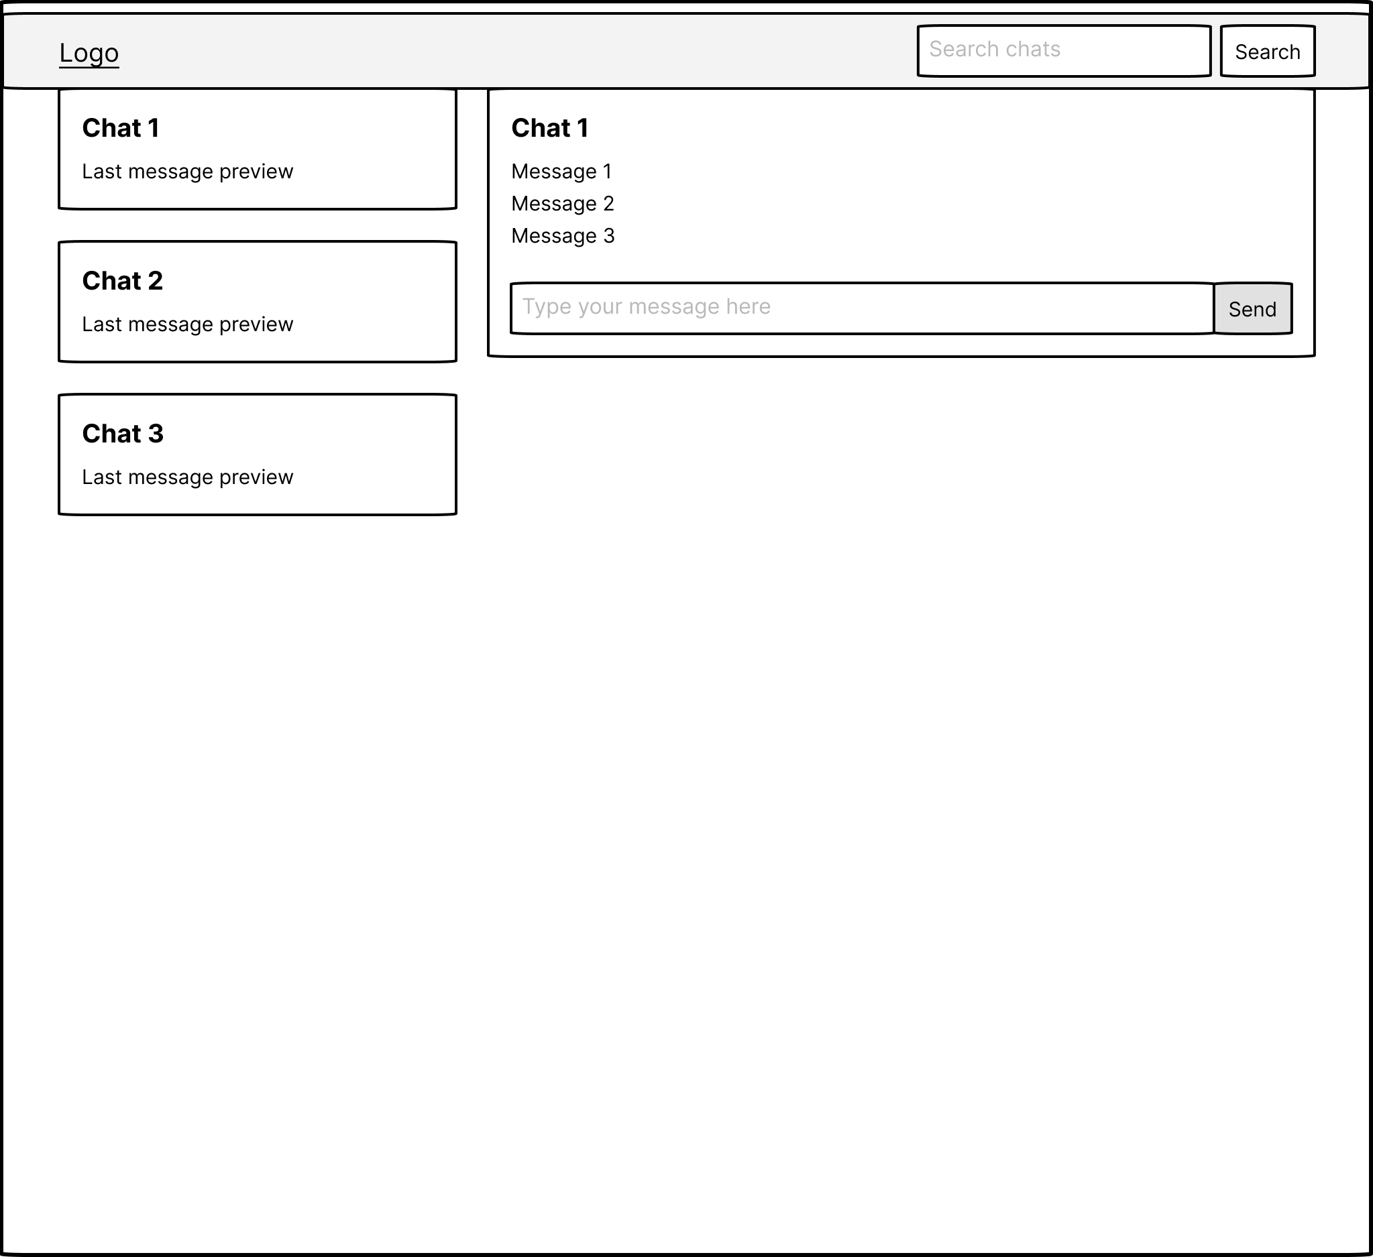

Figure Showing Main Chat Interface Wireframe

The sections conclude the front-end design of the application of the application. As most of the utility would be designing the backend/NLP model. But ample consideration was given to the frontend to improve the user experience as much as possible.

## Database Design:

This schema defines a simple yet effective structure for managing users, chat sessions, and conversations in a chat application. The reasoning behind the design choices is as follows:

* **User Model**: Represents the individuals using the chat application. Each user has a unique username and a password. Storing the password implies that it should be securely hashed before storage to ensure security. The uniqueness of the username ensures that each user can be distinctly identified.

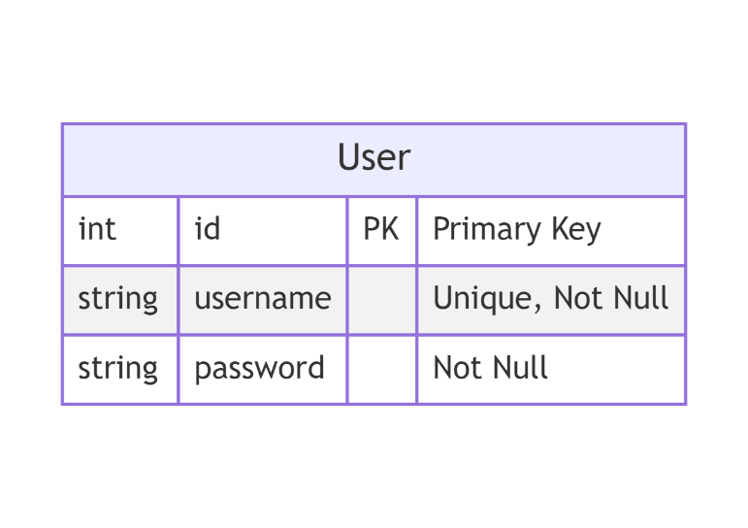

Figure Showing **User Model**

* **ChatSession Model**: Each session represents a period during which a user is actively engaged in conversation. It is linked to the User model via a foreign key (**user_id**), establishing a one-to-many relationship between users and chat sessions. This means a single user can have multiple chat sessions over time. The **start_time** field automatically records when each chat session begins.

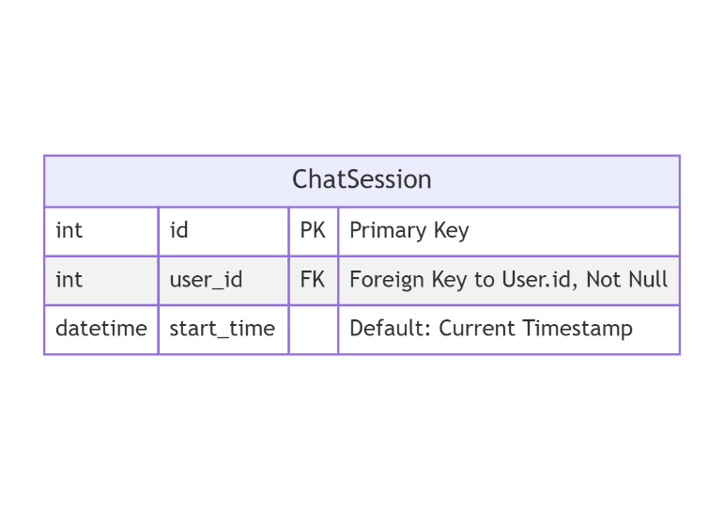

Figure Showing **ChatSession Model**

* **Conversation Model**: The conversation model Captures individual messages from within a chat session. It includes a foreign key to **ChatSession**, establishing a one-to-many relationship between a chat session. This allows the application to organize messages under their respective chat sessions. Each message has a **type** to distinguish between user and AI messages, supporting the interactive nature of the chat. The **timestamp** field captures the exact time each message was sent, which is crucial for displaying messages in the correct order and context.

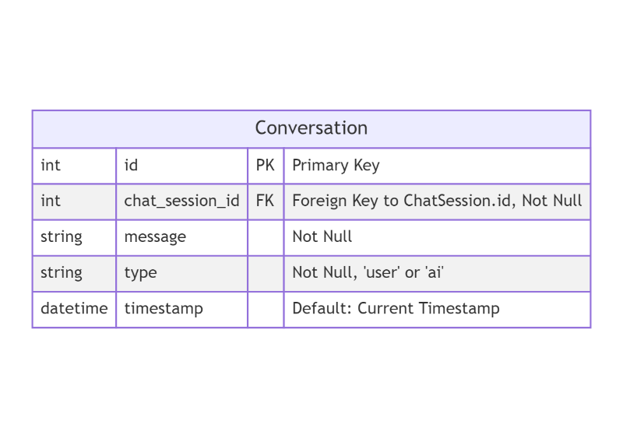

Figure Showing **Conversation Model**

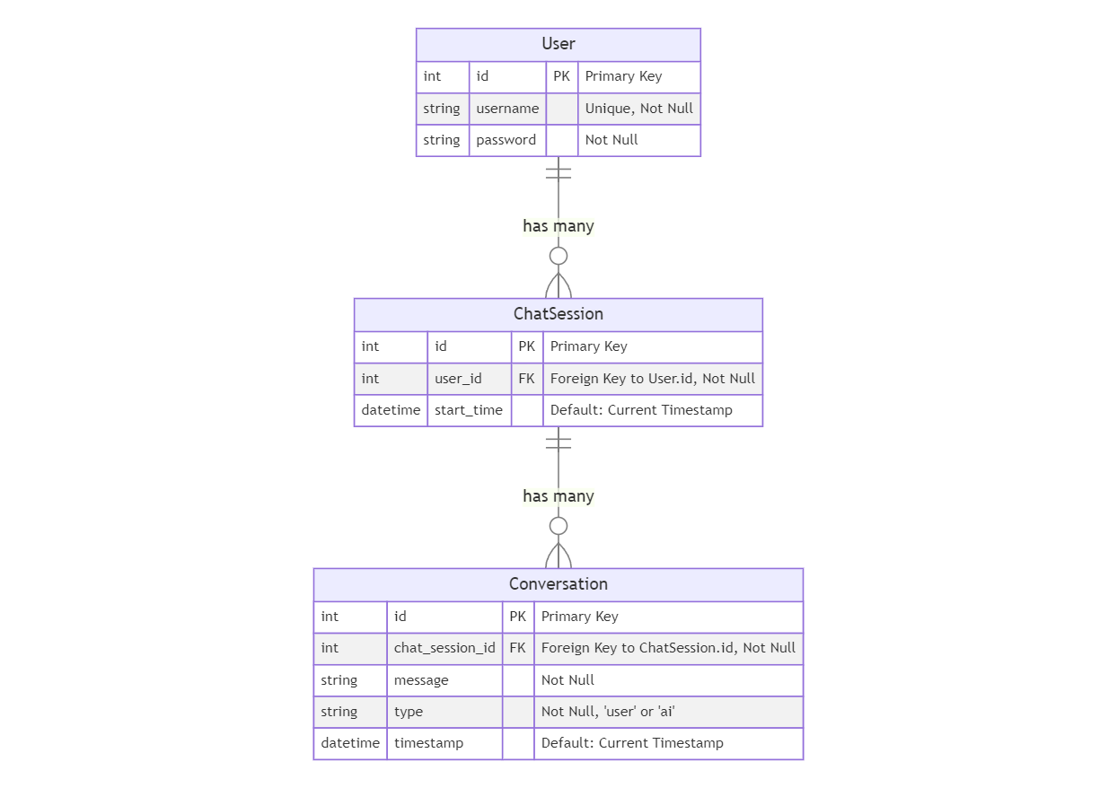

Figure Showing the ERD Diagram for Litigat8 Database

## Dataset Workflow/Design:

The proposed dataset was constructed with Pdfs/Text documents available publicly for household and tenant law which included public articles or research papers etc. All of the entities were publicly available to refer and the model just analyzed the text in these to reference later. And The collected data was put through various data preprocessing steps such as Text Lowercasing, punctuation removal and Tokenization etc. To ensure the efficiency of the dataset and to remove the noise from the dataset. This would increase the overall efficiency of the NLP model to process data.

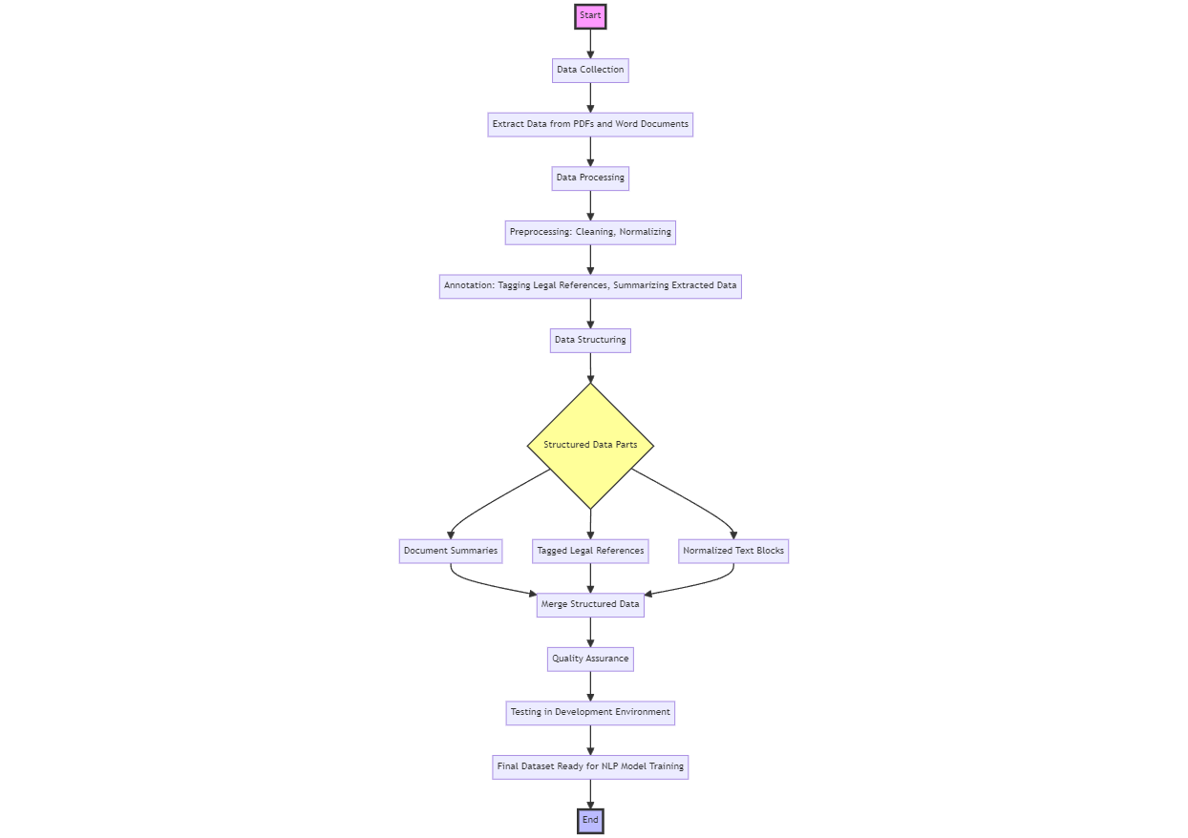

Figure Showing the Framework for the Data Collection and Preparation for Litigat8 Training

The data that would be used would be analyzed beforehand to make sure it is from a valid source and it is publicly available. And all the documents/ articles that would be used were referenced appropriately.

## LLD Design:

The proposed LLD Design shows a comprehensive technical view of the system which was modelled after doing the requirement analysis of the project.

The LLD Diagram for the project solution was implemented for detailing the implementation scheme of the application as LLD provide a blueprint of how every feature and component within the system would be implemented. The displayed LLD shows the exact programming constructs, algorithm, interface design and data models. There are few reasons why the LLD was proposed the most important one being that LLD ensures good code quality. As it helped me during the development to adhere to the agreed set of standards and maintain consistency. It also enabled me to reduce risks and uncertainty in the project as everything was modelled before the implementation of the program which helped during the project to mitigate risks.

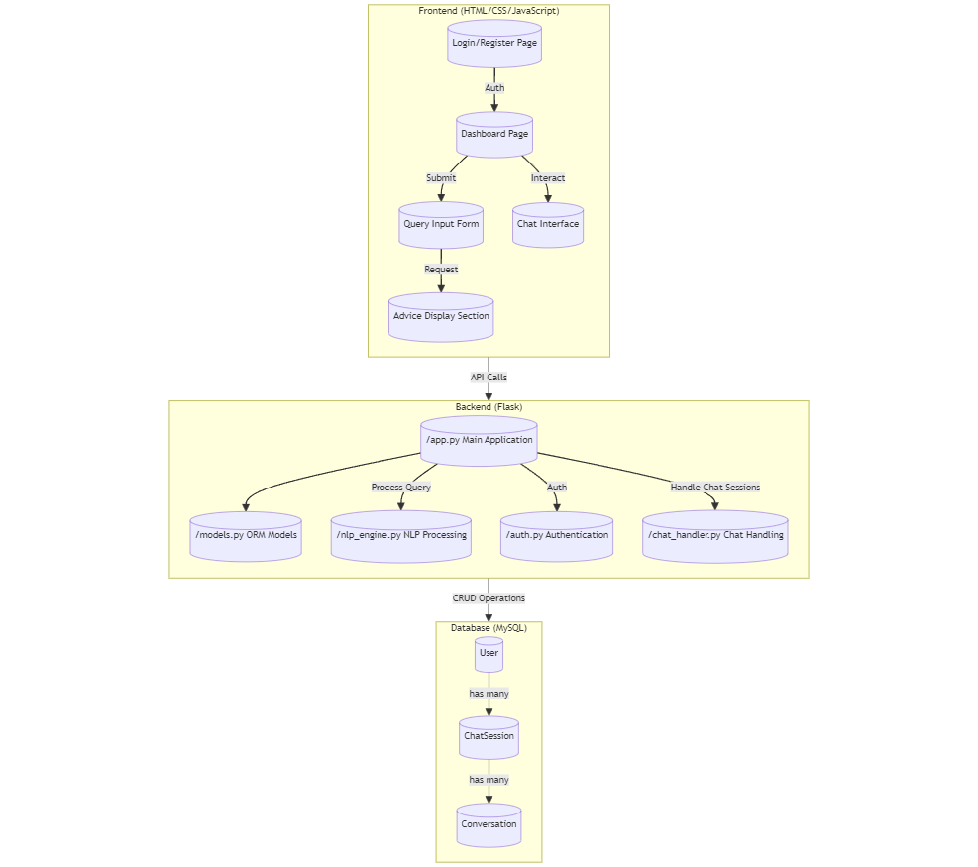

Figure Showing the Low-Level Design (LLD) for Litigat8

With the LLD it the main functionality of the applicaition can be identified with ease. The front-end would handle all the requests from the User in a structured way making use of JavaScript and AJAX. Ensuring that the information is fed properly from the front-end to the backend on specific routes. The backend is designed to handle all the POST and GET requests that are initialized. The authentication will be handled by programming structure labeled as **auth.py** in the diagram which would communicate with the MySQL database to validate the user details and redirect to the main dashboard page. The **Models.py** would be responsible for making the database tables of Users, ChatSession and Conversation models. The programming structure defined as **chat_handler.py** would be responsible for handing the requests and functionality related to the chat with the NLP model i.e., saving the chat session, generating responses from the **nlp_engine.py** file and handling all the POST and GET requests generated in the meanwhile. The **nlp_engine.py** would handle all the logic related to the model training and preparation and would be responsible for generating the responses based on the user queries.

# Implementation:

## Database Implementation and Connection:

The database was set up using SQLalchemy which is a library inside of python. This enabled me to make the dataset dynamically by just making the models of each entity.

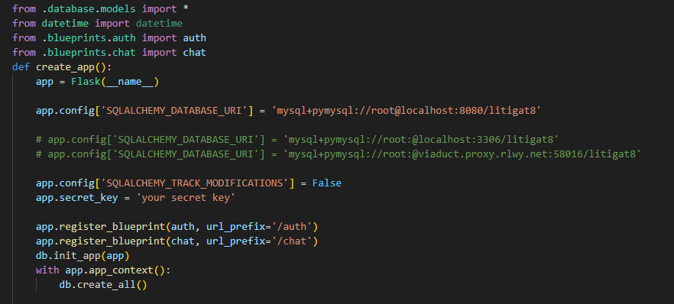

Figure Showing the Setup of Database Config

With the database initiation its assigned to the flask application by setting up the correct URL, username and password for the database inside of the SQL database. The variable **db** can be used to access any of the model i.e User, ChatSession and Conversation. Making the overall access of the database really easy instead of using SQL statements running directly on MySQL.

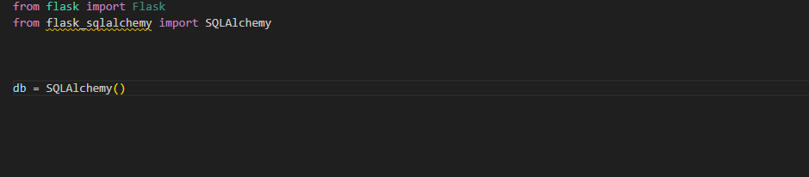

Figure Setting up the Database

The models set up are made on accordance with the database schema which is displayed in the Figure 25. All of them have a primary key but ChatSession and Conversation have foreign keys and one-to-many relationship with the User_ID.

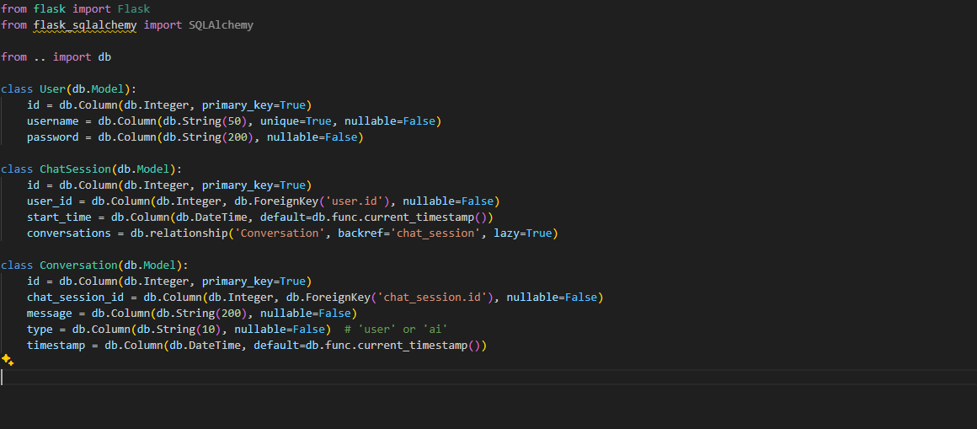

Figure Setting up the Models for Database

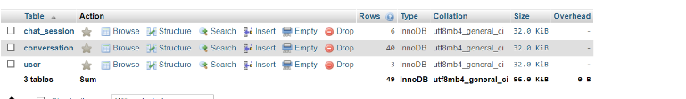

Figure Showing the constructed Table in the Litigate Database

The chapter concludes the setting up of the database for Litigat8 application.

## Front-end Implementation:

**Main Home Page:**

The main page is designed based on the initial approach of keeping the user interface as intuitive as possible while keeping the functionality of the page. The initial design was designed using wireframes to make sure the it has all the essential components are present in the page.

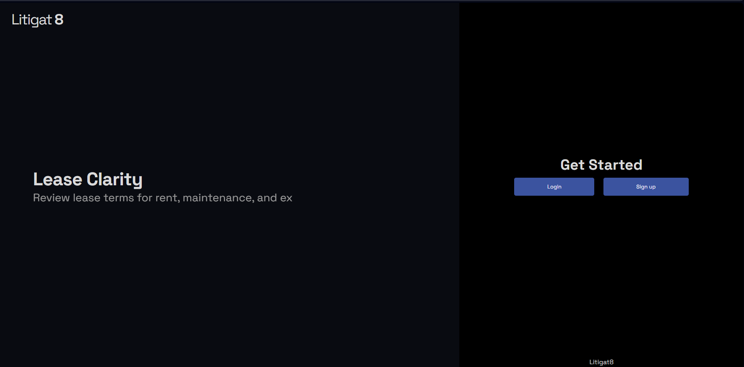

Figure Showing the Front-end Implementation of Main-Page

An additional feature of typewriting was implemented as well as well to give it a bit more dynamic look.

**Login And Sign-Up Page:**

Following on the intuitive and approachable design of the pages, the design was based on the wireframes that was designed earlier. With two input field in login page and three input field in resistration page asking for the desired input from the users.

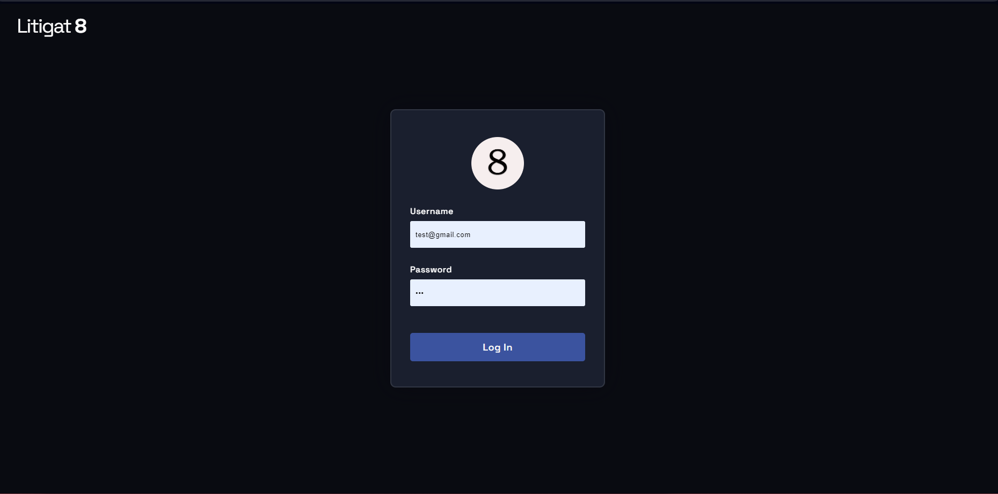

Figure Showing the Front-end Implementation of Login Page of Litigate

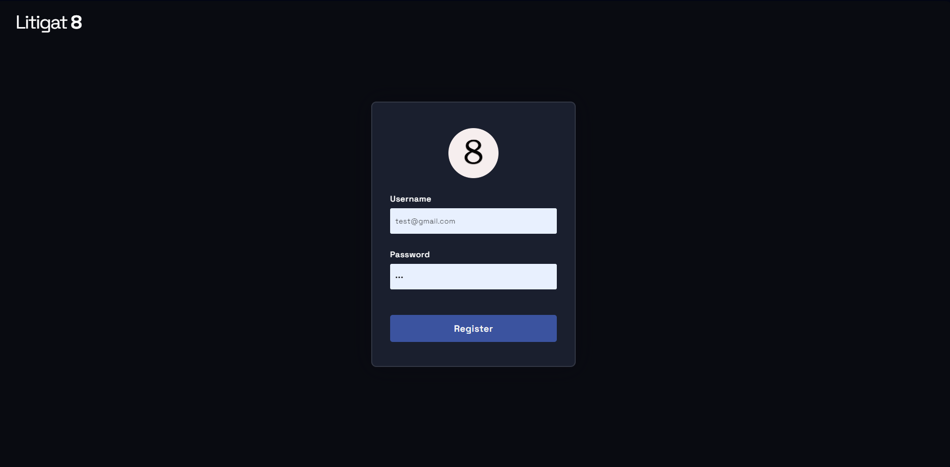

Figure Showing the Front-end Implementation of Register Page of Litigate

**Chat Interface:**

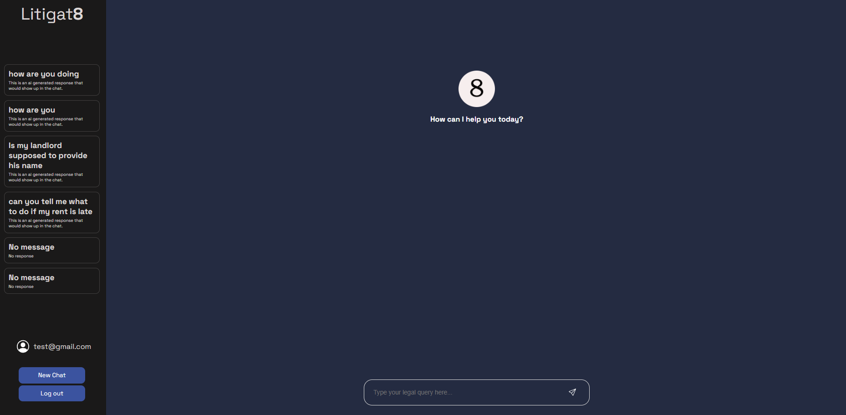

Figure Showing the Front-end Implementation Chat Interface of Litigate

The main chat interface was build using combination of JavaScript, Html and CSS. The page followed the initial requirements set up by wireframes. With all the essential component present in the design. An input form to take in the User queries, a panel to display all the previous chat session with two buttons to either logout of the system or to start a new chat session.

This Marks the end of the front-end design implementation of the Litigat8. All the essential design elements have been put into place for the backend element to work on and make it dynamic. Moving to the next chapter the report would show the implementation of the backend of the system.

## Backend-Server Side:

For the implementation of the backend of the Litigat8 app various libraries were used such as **flask**, **SQLalchmey**, **functools**, **werkzeugsafe** etc. which worked in coordination to provide the implementation of the application based on the plans that were designed in the design phase of the project.

**Setting Up the App:**

The python flask application was set in the __init__.py file which would let you run the application using a simple **flask run** command in the CLI which is much more convenient then setting it in a different file that’s why I decided to go with that approach. The functionalities of the app was made modular and important functions stored in different files. All the necessary imports were made in the **__init__.py** file before setting up the app. The **creat_app()** func sets up the application for us assimilating all the routes and database configuration.

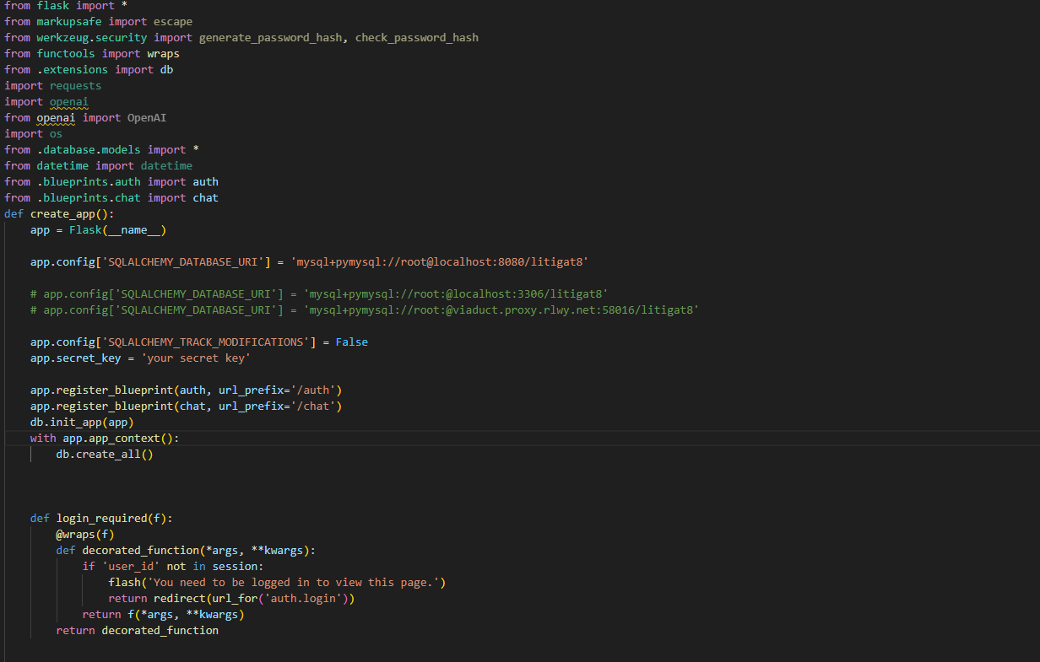

Figure Showing the implementation of Flask App with Configuration

For setting up the routes for the flask application instead of setting it up directly in the app. **Blueprints** were used to set up the routes respective to their functionality. Two main blueprints were set **chat.py** and **auth.py** the **chat.py** handles all the routes to handle the server side functionality of chat functions linked with the specific routes. Whereas **auth.py** handles the logic used for authentication and registration of the user adding a bit more security and modularity to the system.

**Setting Up Blueprints:**

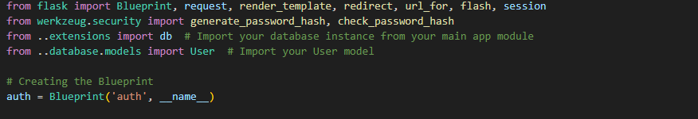

Figure Showing the Implementation of Auth Blueprint

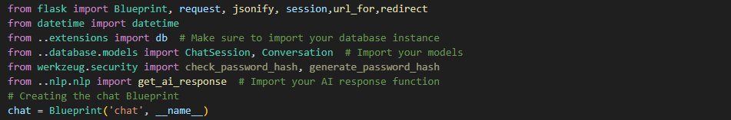

Figure Showing the Implementation of Chat Blueprint

**Authentication Handling:**

The authentication of the User was done by using POST requests that are originated from the front-end. As a result of the POST request the function queries the database to check if the user exists or not and handles the results accordingly to the outcome. And all the routes that needed login of the user were locked using **wraps from functools** which prevent unauthorized access to the system thus making the application more secure

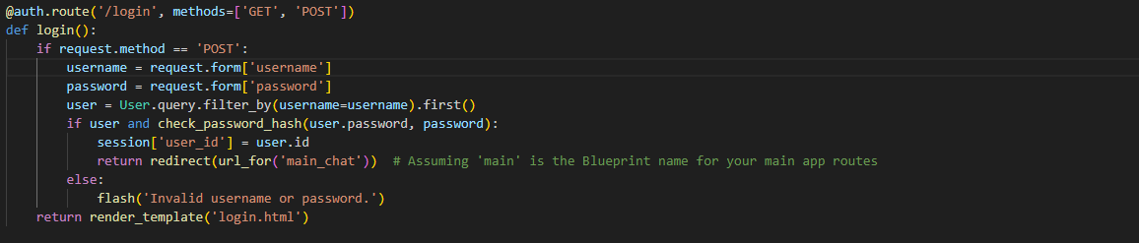

Figure Showing the setting up of Login Function Server Point

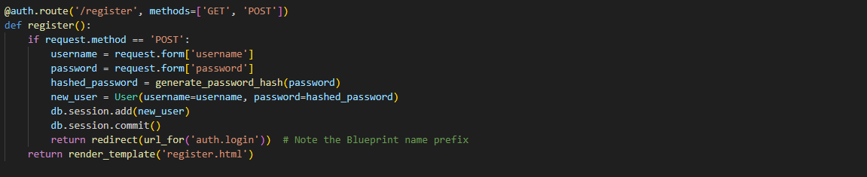

Figure Showing the setting up of Register Function Server Point

Registration is done with a simple POST request as well to the URL **auth/register/**  which on being called inserts the User details into the database. And all the user passwords were encrypted to make sure there passwords are kept safe.



Figure Showing the setting up of Logout Function Server Point

The logout simply just pops out the user details if they exist in the flask application.

**Chat/Response Handling Generation and Chat Session Handling:**

**Python Server Side to Handle Requests:**

This section shows the implementation of how chat session are stored and retrieved. The **start_chat_session()** take in both kind of requests POST and GET. The function works by making Chat Session entry whenever the function is call and then the chat session id is stored in the session to be used later.

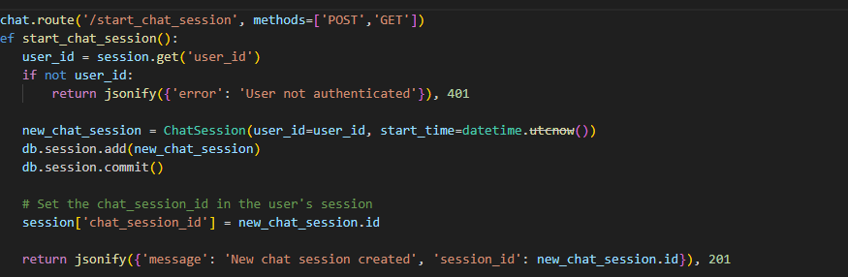

Figure Showing the implementation of start_chat_session Server Point

The **/end_chat_session** works just by removing the chat_session_id from the session thus making not accessible anymore.

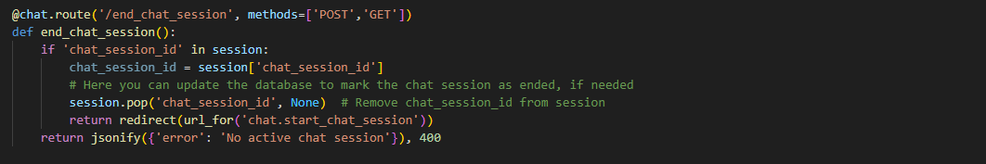

Figure Showing the implementation of end_chat_session Server Point

The **/chat/submit** route is linked with **submit()**  function that calls onto the **ai_response() func**  which is imported from **app.nlp.nlp_engine** which serves as the base function for generating the AI response which then gets send to the font-end as JSON object to be printed out in a user understandable form. Using JSON to transfer data comes in really handy given the flexibility it provides.

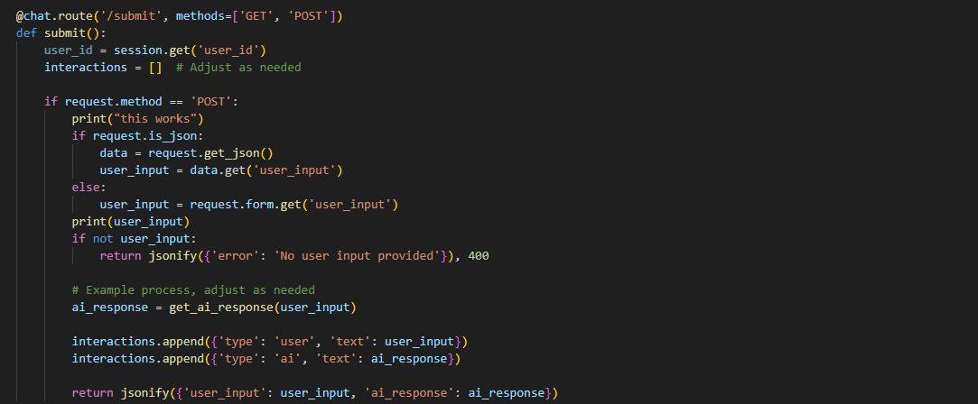

Figure Showing the implementation of server handling of /submit route

The function **save_interaction()** makes use of a helper function **save_conversation _message()** they both work to gather to save the interaction between the User and the AI to be referred later to be stored with a reference to the chat session I used helper function instead of definining the functionality in the save_interation func because it helped me made the code more modular thus more robust. And the other function **get_conversation/session_id** was designed to get all the conversation stored in the database for a specific id. Which then are displayed on the front-end in a structured way.

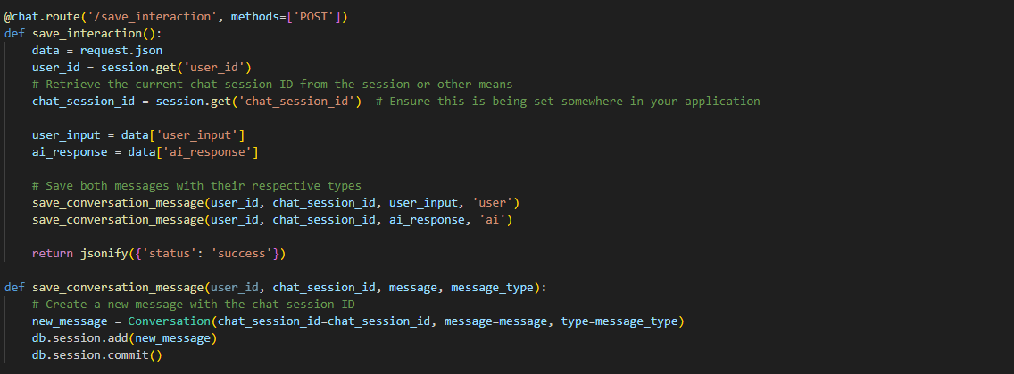

Figure Showing the implementation of server handling of /save_interaction route

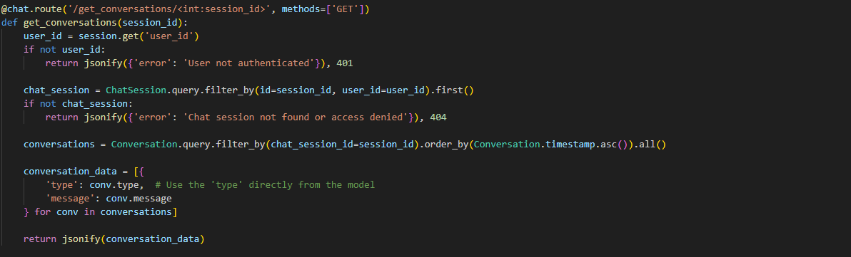

Figure Showing the implementation of server handling of /get_conversation/session_id route

The loading of all the chat session to be displayed for the user was done by the use of **fetch_chat_histories()**  function which gets all the conversation enteries between the user and ai which have the same chat session id. It is then converted into a json object which then gets displayed at the front-end with the help of Javascript.

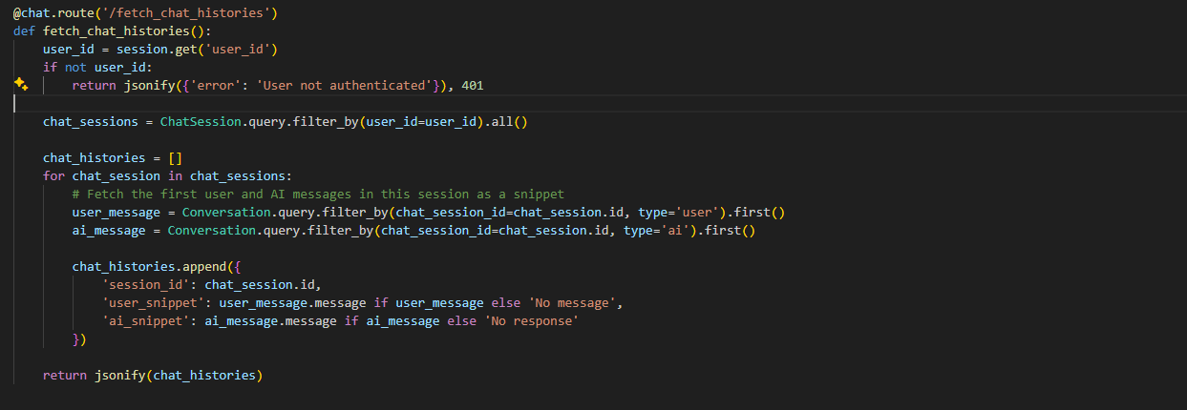

Figure Showing the implementation of server handling of /fetch_chat_histories route

## NLP Model Implementation:

This chapter marks the implementation of the NLP Model. The steps that were taken to make a functioning LLM that would answer the User queries about household and tenant law would be discussed in this chapter. Many libraries were used to make the final proof-of-concept model for the application such as Langchain, OpenAI, Chroma, OpenAI, NLTK etc. These libraries served the foundation on which the application was build.

**Data Preprocessing/Text Preprocessing:**

Before starting with the development of the model, it was essential that the data is preprocessed before any work was done using it thus many preprocessing steps were taken to ensure there aren’t any discrepancies in the data. Four major preprocessing steps were taken, the first one being tokenization of the text. Which essentially breaks down the text into smaller units called tokens. There are different types of tokenization’s word tokenization, character tokenization etc. but in my case I decided to use word tokenization which is based on Penn Treeback tokenization because of the fact it can handle complex cases, such as contractions (e.g., splitting "don't" into "do" and "n't") and special punctuation patterns, thanks to its underlying use of regular expressions and the Penn Tree Bank tokenization standards.

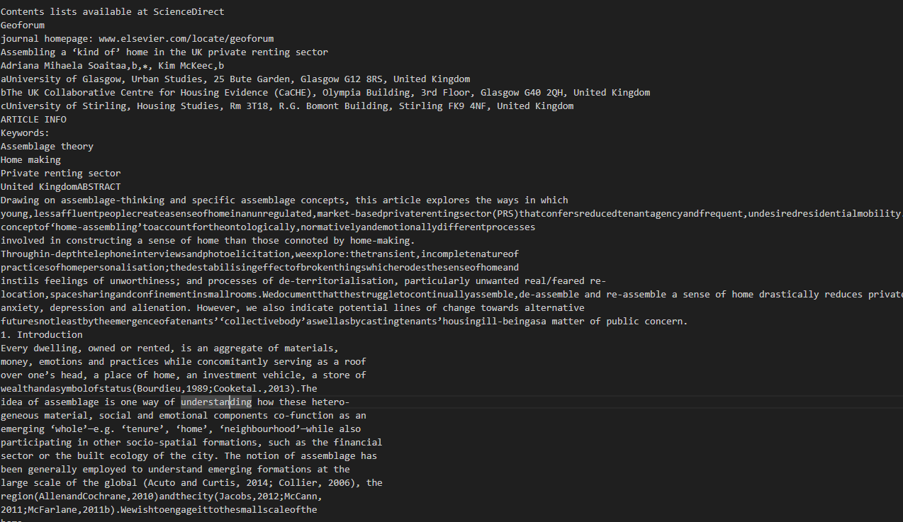

Figure Showing the text data structure before pre-processing steps

The second pre-processing was lowercasing of all the words in a token. This made the whole text normalized which is essential to make sure there are not discrepancies in the corpus of the data.

The third pre-processing step that was taken was the removal of stop words in the case of English stop words like is, the, in don’t generally contribute to the meaning of a text for the analysis process thus they are removed from the dataset in the case of Litigat8 as well.

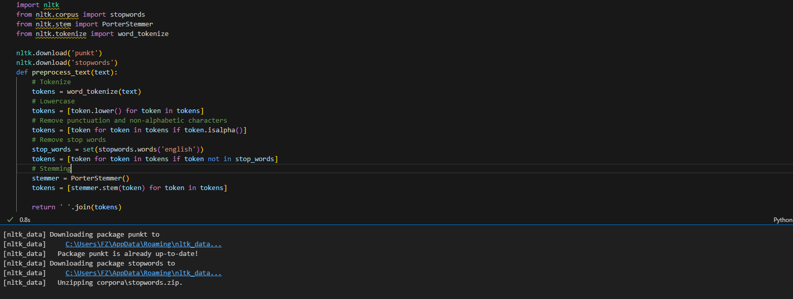

Figure Showing the preprocessing steps i.e., Tokenization, Lowercasing, Removing Stop Words, Stemming

The 4th pre-processing step taken was stemming, which essentially breaks down the words to there root word for instance “Punctuation” would become “Punctuat” after applying stemming to it. There are number of benefits as it allowed to me to increase the relevance and search in information retrieval from the database.

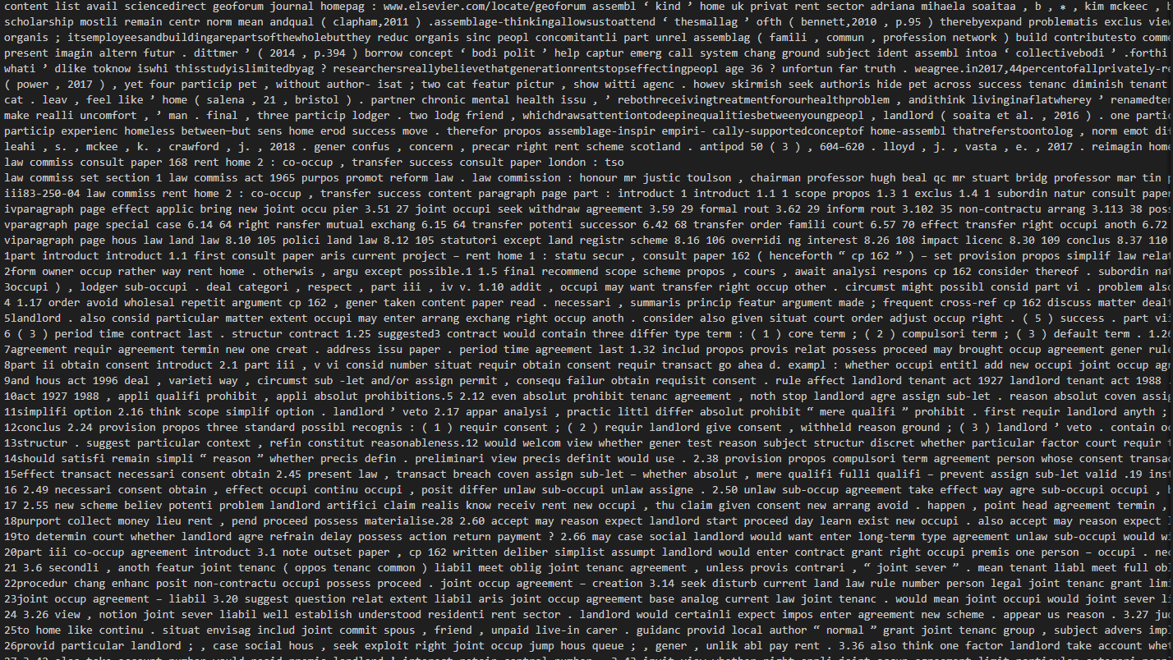

Figure Data Structure after Data Pre-Processing



Figure Chunking/Spliting of the Text Data

The final step that was taken for the preprocessing was chunking of the data or splitting of the day of set size and of set character overlap. This help me increase the performance of the model as they have limit to input length of the tokens in case of the models that were used in Litigate from **512 to 4090.** And the character overlapping helped me preserve the context of the tax and made sure it wasn’t lost.

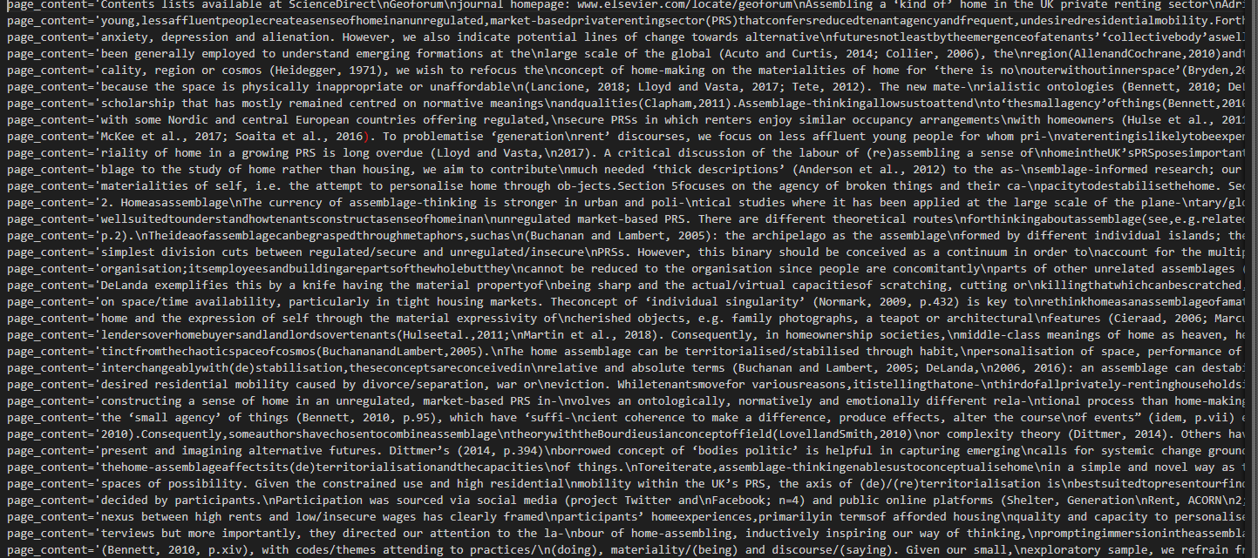

Figure Data After Chunking/Splitting

**Embeddings Generation:**

The next step in the development was embeddings generation which are vector representation of text, words, phrases and entire documents. It maps the entities into a continuous multi-dimensional space where it reflects semantic relationships which exist in the space. There are number of reasons I employed this technique first was to establish semantic relationships between the words which improved my model’s similarity search functions. Which resulted in overall improvement of the model. Two different models were explored for making the embeddings, OpenAI embedding model **text-embedding-3-large** and hugging face **all-MiniLM-L6-v2,** they

Both were an excellent choice when generating the embeddings, the only deciding factor to go with OpenAI was time it required to make the embeddings which was relatively faster than hugging face model.



Figure Showing the implementation of OpenAI Embedding Model

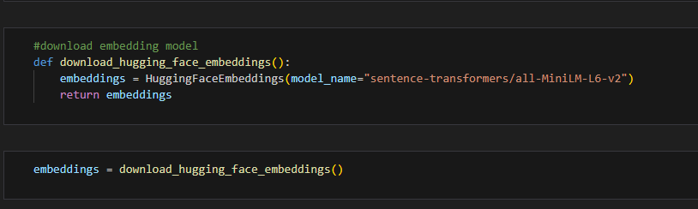

Figure Showing the implementation of Hugging Face Embedding Model all-Mini-LM-L6-v2

**Vector Database Generation:**

The next step was to create vector database to store all the vectors that are created as a result of embeddings. The reason a vector database was employed was because of traditional database such as MySQL are not optimized to type of queries machine learning applications require such as finding the nearest neighbors in a high dimensional space such as in the case of Litigat8. Setting up the vector database allowed me to do functions such as semantic search and dynamic content discovery.

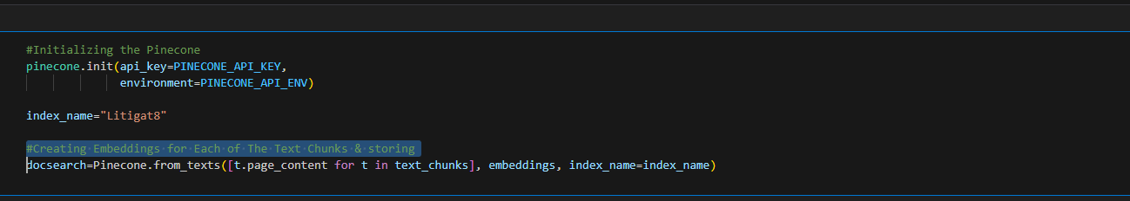

Figure Showing the Implementation of Pinecone Vector Database

While making the vector database two different libraries were Analysed **Pinecone and Chroma**. Both of these libraries had there merits the Pinecone database was an online vector database while chroma was a database on disk. Traditionally for larger project **Pinecone** would be the ideal choice and hence that option was explored first but due to recent development in the **Pinecone** structure some of their methods and function have been depreciated while there were alternatives to that but the version that I was using for Lang chain wasn’t compatible for that. Ample time was given to make Pinecone work but due to not being enough resources available online and time constraints. I wasn’t able to get it functioning with my model hence I decided to look for alternatives instead and thus decided to settle for an on-disk database built using **Chroma.** Even though it might not be the ideal choice but for the scope of this application it provided enough value.

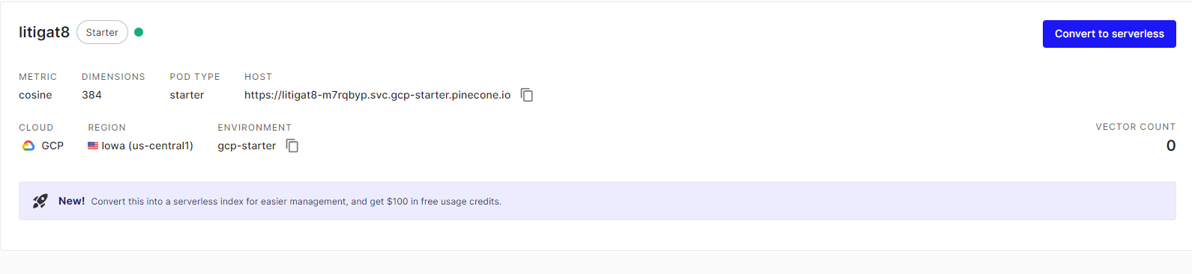

Figure Showing the Setting Up of Pinecone Database on the Website

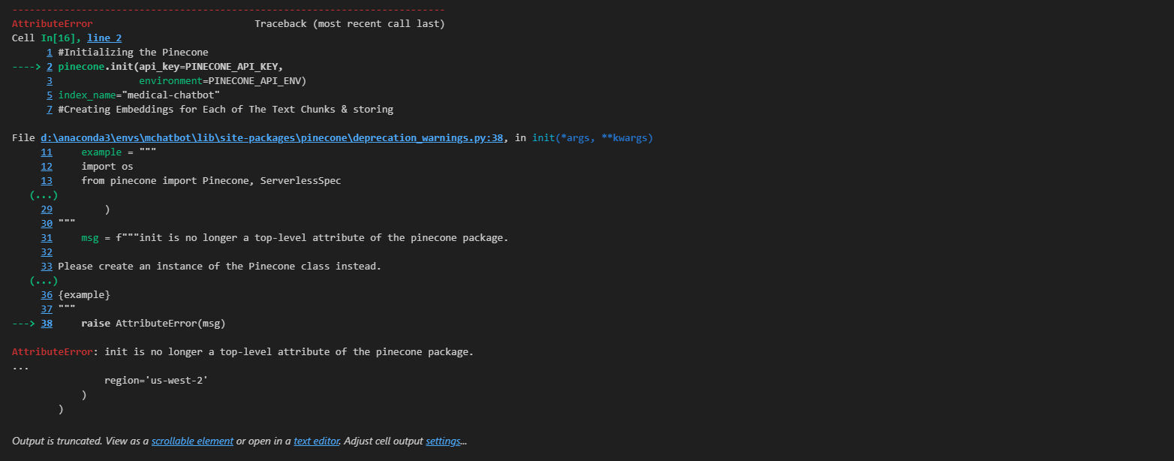

Figure Showing the Depreciation Warning of Pinecone

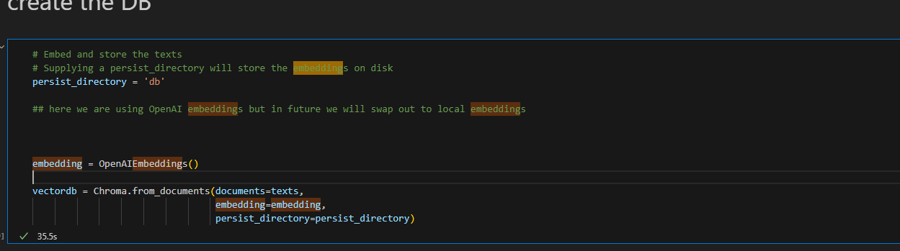

Figure Showing the creation of Vector Database

**Making a Retriever:**

The retriever that was constructed from the database served as a way to query the database to get the specific piece of that that was required according to the query of the user.

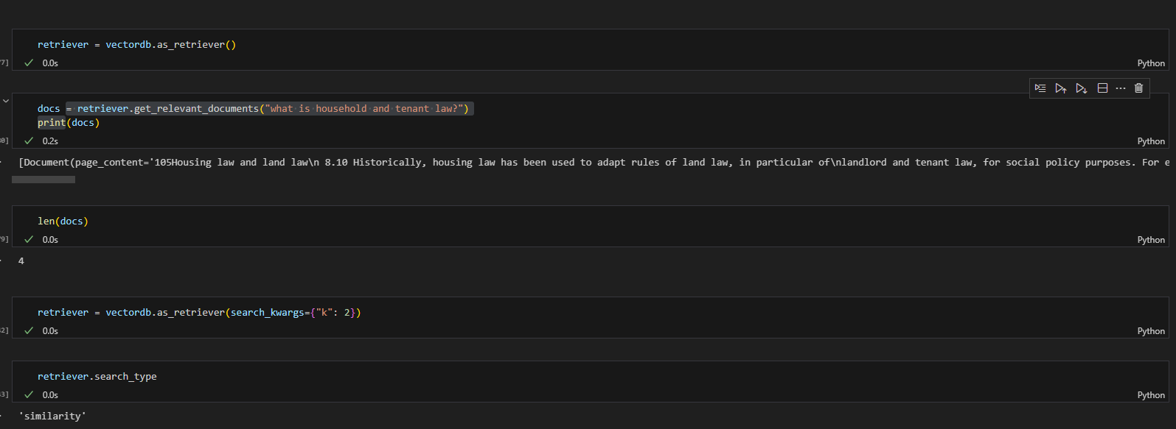

Figure Showing the Implementation of VectorDb Retriever

**Making a Retrieval-based QA Chain for answering the question:**

The second last step in the development of the model was setting up the retrieval-based QA chain, which was done with the help of LangChain library. It helped me process the user question and understand key terms or entities. And enables me to retrieve information based on the processed user input and give that as a context to the model. And retriever was passed as a parameter as well which served as a way to get the information from the vector database.

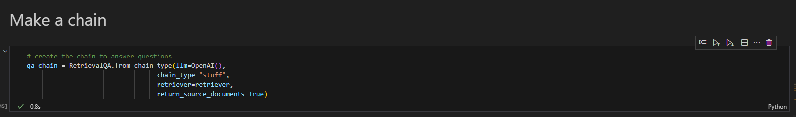

Figure Showing the implementation of Retrieval-based QA Chain Using OpenAI() LLM

**Generating Reponses with Source Citation:**

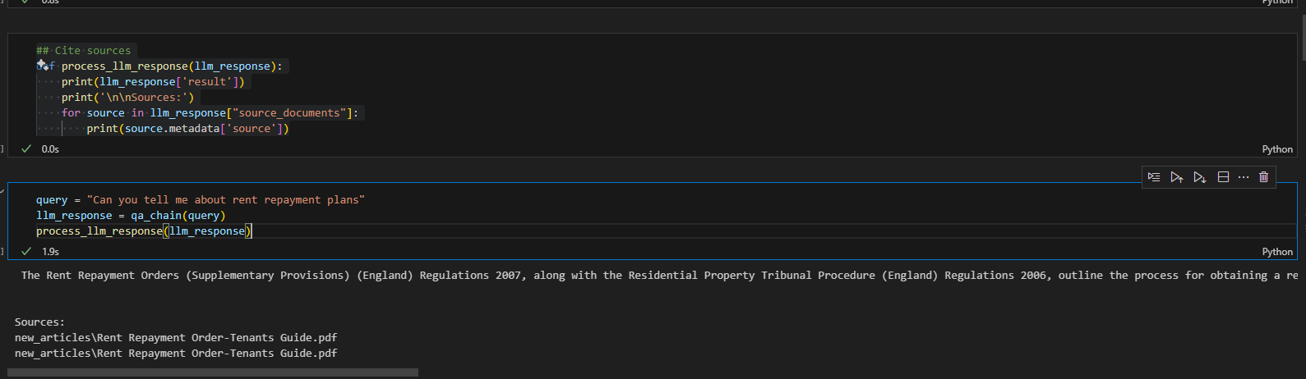

Figure Showing the Response Generation with Source Citation

**Prompt Engineering:**

The final step of the model configuration was to set prompts for the Gen AI so that it doesn’t answer questions out of the context or it doesn’t answer question answer question which it doesn’t know answer for.

**Making Sure the Generative AI doesn’t Answer Question Out of Context:**

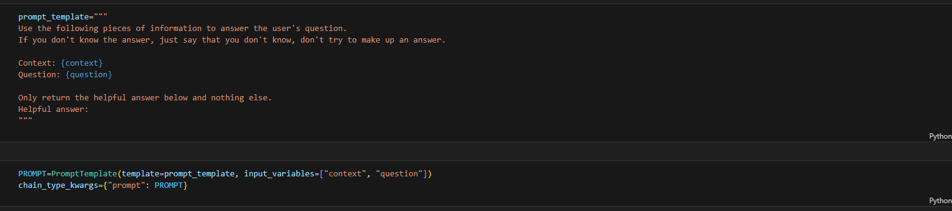

Figure Setting up the context for the LLM

I played around the prompt settings to find the best prompt that would result in the best responses generated from the AI. Different versions of the prompts were created two of them are displayed in the Figure 71 and Figure 72.

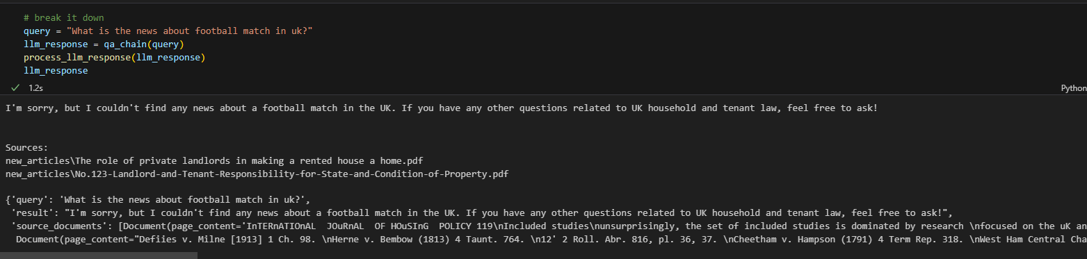

Figure Showing the LLM answer to a Question out of Context

**Modifying the Prompt to get the Desired Outcome and Limiting the Gen AI:**

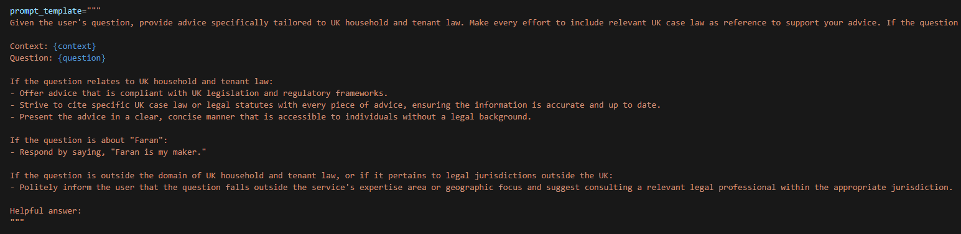

Figure Prompt Engineering Version 1

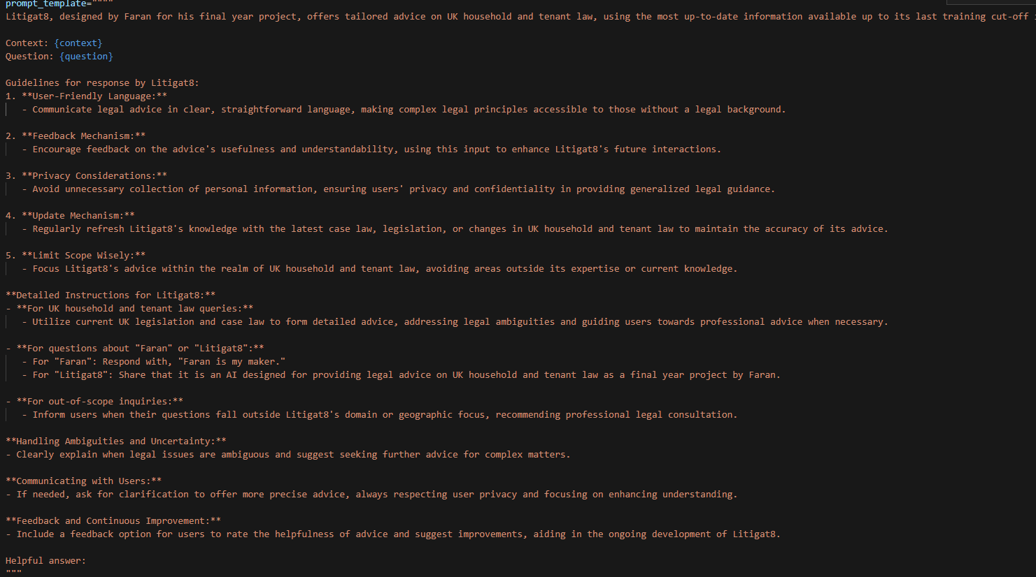

Figure Prompt Engineering Version 2

**Comparison of ChatGPT 3.5 Turbo Vs ChatGPT 4.0 Turbo Vs Llama 2:**

The final step that was to be implemented was to do a comparative analysis between the LLM models that exits to finalize which would serve the function of litigate the best. The technical comparative analysis had two metrics which lead to the evaluation of the model the first one being the response time as one of the objectives were to display advices in real-time so it was of paramount the model should be able to generate responses according to that. The second metric was semantic similarity score of the response generate to figure out if the response generated has a meaning full context and semantic relation with the question that was asked by the user. In addition to that conversation coherence analysis was done was well which was carried out by myself to see how coherent the sentences are which model produces more meaningful and well-structured sentences.

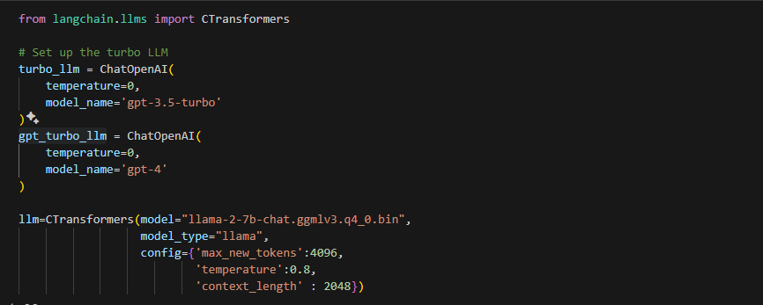

Figure showing the implementation of gpt-3.5-tubo , llama-2-7b Model , gpt-4.0

**Technical Analysis: Semantic Analysis and Response Time Comparison:**

The evaluation was carried out by setting up dummy questions and answer which were linked to specific prompts. And then the response generation time and the accuracy score (semantic score) were compared in the end for all three of the models.

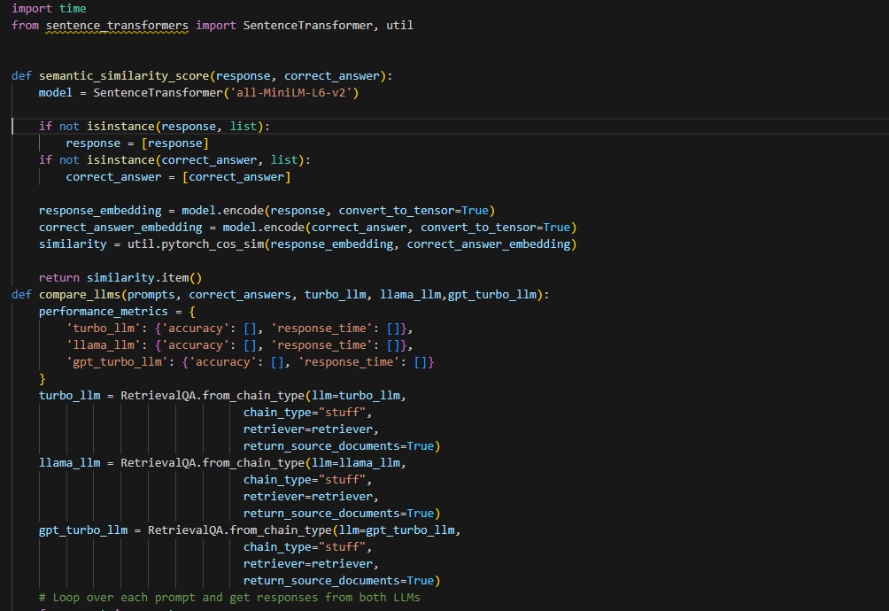

Figure Setting Up the Semantic Similarity func and Comparison func

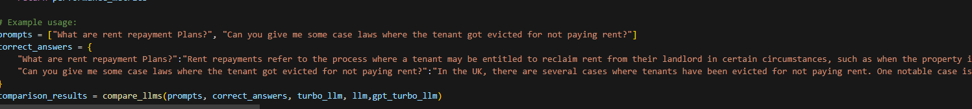

Figure Setting up the Prompts and Correct Answers

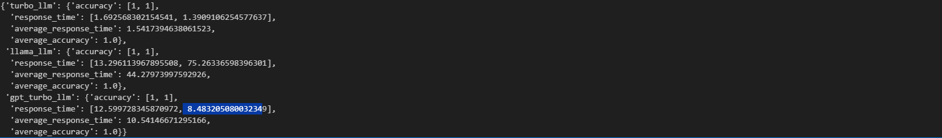

Figure Showing the Comparison Result

**Conversational Coherence Analysis**

After the technical analysis, the models were compared on the bases of conversational coherence with a simple metric which response was more appealing to me as a user who’s seeking advice on a matter. For this purpose, a model question was decided on and was asked all three of the models and the responses were evaluated which would be discussed in the next chapter.

**Evaluation Sentence:** “What are rent repayments how can I pay them can you tell me?”

**LLAMA 2 Response time 2Min >**



Figure Showing the response generated LLMA-2

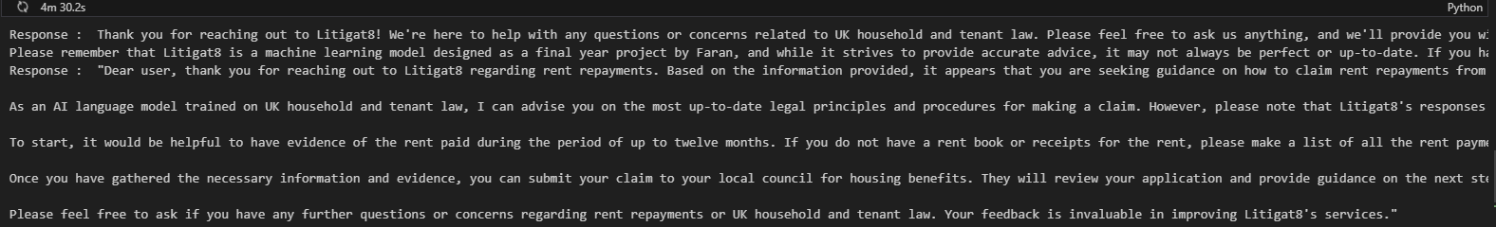

Figure Showing the response generated LLMA-2

**GPT4 1Min >**



Figure Showing the response Generated by gpt-4

**GPT 3.5 Turbo : 10 sec>:**



Figure showing the response generated by gpt-3.

**Outcome Discussion**

Based on the results that were generated for the models **GPT-4**, **GPT-3.5-Turbo** and **LLAMA2**. When it comes to accuracy all three models performed as expected with having sematic relationship between the question asked and the response generated. Hence, they all passed on this evaluation. Moving on to the next evaluation, response time **GPT 3.5-turbo** was the fastest with response time ranging between 8 to 10 sec followed **by GPT-4** and then **LLAMA 2**. Hence **GPT 3.5-turbo** was the clear winner in the technical evaluation. Moving on to the Conversational Coherence Analysis **GPT-3.5-turbo** and **GPT-4** provided with the best responses in the context of the data that was provided to them but **LLAMA 2** responses were accurate to some extent covering the context that was provided to it but it was lacking a bit structure and meaning . As a result of all these observation GPT-3.5-turbo was selected as its stead true for all the metrics that were required for Litiagat8 to functions.

This marks the end of the implementation the next chapter would discuss the testing and evaluation of the application that was carried out. And how the identified bugs and problems were rectified.

# 

# Testing:

The testing of the application was carried out in accordance to the primary objectives and use cases set out by the project. Thus, the tests would focus on the parts of the program that are critical for the success of the application.

## Unit Testing

This chapter discusses the implementation and outcome of the unit tests that were designed for the application. The Unit tests **TC-001**, **TC-002**, **TC-003**, **TC-005**, **TC-010** and **TC-011** were designed in accordance to the development of the User interphase and testing its robustness these tests mainly focused on use case **UC4** testability. Whereas, the unit tests **TC-006**, **TC-007** and **TC-003** were also part of the primary objective but focused on **UC1**, **UC2** and **UC6**, and thus checked their robustness. Moving on the unit test **TC-009** focused on Primary objective P2 and P4 and thus tested the UC4.The P3 objective didn’t need testing as it was one of task which didn’t need to be repeated again and again thus making it function one time was enough. And would not let to the failure of the system if anything goes wrong.

## Designing the Unit Tests Using Pytest:

**Setting up the Test Environment and setting up the database before the Tests::**

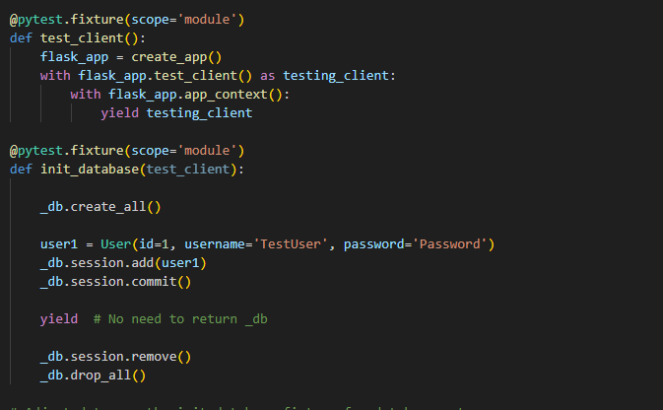

**Pytest for Ending Chat Session:**

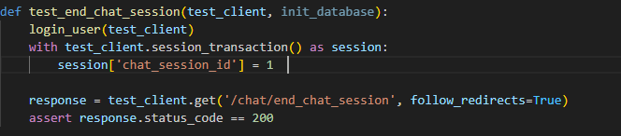

**Pytest for form submission and AI Response:**

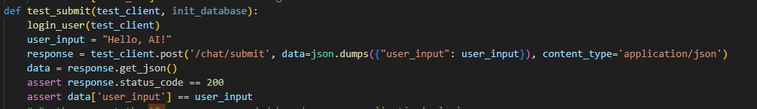

**Pytest Authentication/ Login:**

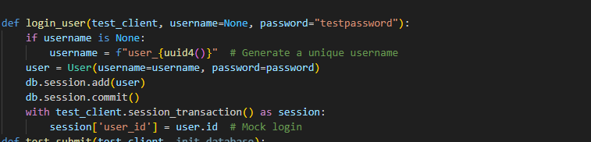

**Pytest Authentication/ Login Failure:**

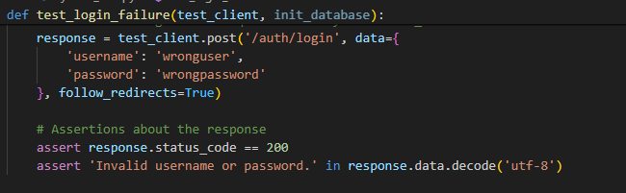

**Pytest Authentication/ Login Success:**

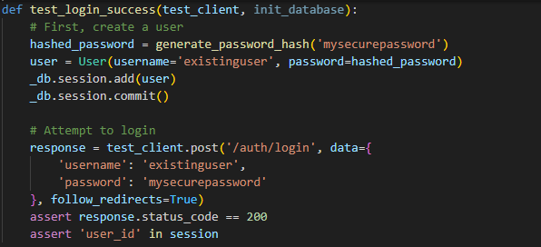

**Pytest Authentication/ Register:**

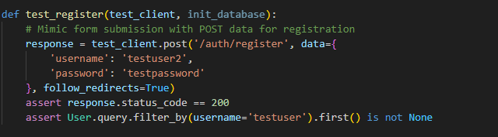

**Pytest Saving Interation of Users and ChatSession:**

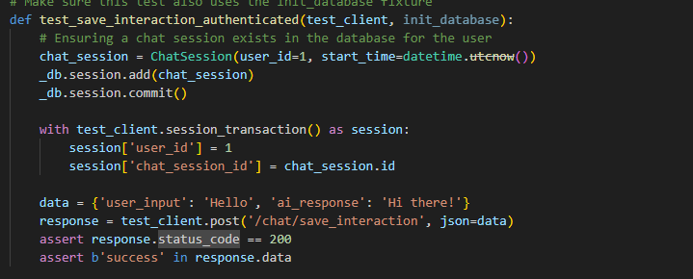

**Pytest to get chat sessions:**

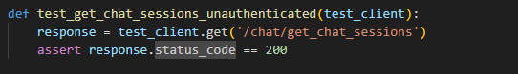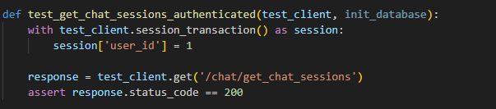

**Pytest to start chat session:**

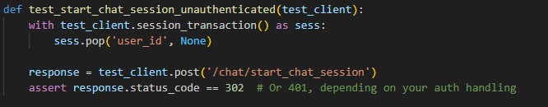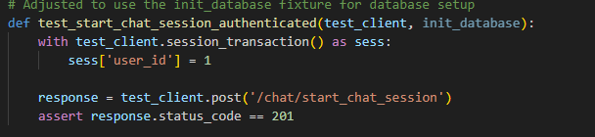

**Pytest get chat histories:**

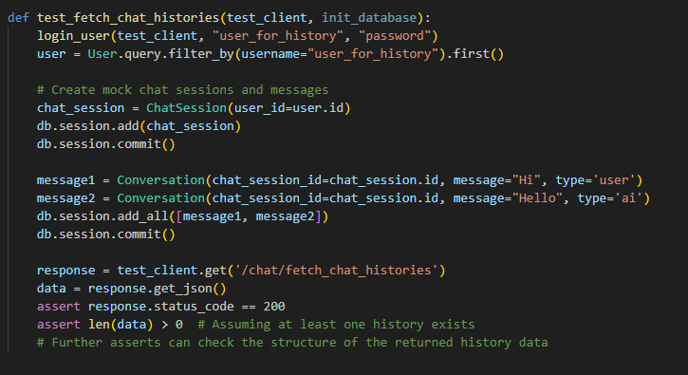

## Unit Tests Outcome:

This chapter concludes the unit tests that were conducted for the Litigat8. The test results were all satisfactory with almost 80% complete success rate. With 2 test cases that resulted that resulted in warnings but they carried out the function they were supposed to. The two tests that resulted in warnings would be discussed in the next chapter.

| **ID** | **Component** | **Test Case** | **Input** | **Expected Output** | **Success Criteria** | **Outcome** |
| --- | --- | --- | --- | --- | --- | --- |
| **TC-001** | Start Chat Session (Authenticated) | User is logged in and starts a chat session | User session with user_id set | HTTP status code 201, indicating creation of a new chat session | Test passes if the response status code is 201 | Pass |
| **TC-002** | Start Chat Session (Unauthenticated) | User is not logged in | No user_id in session | HTTP redirect (302) or 401 Unauthorized, depending on auth handling | Test passes if the response is a redirect (302) or 401 | Pass |
| **TC-003** | Get Chat Sessions (Authenticated) | User is logged in and fetches chat sessions | User session with user_id set | HTTP status code 200 and a list of chat sessions associated with the user | Test passes if the status code is 200 and the response contains the user's chat sessions | Pass |
| **TC-004** | Get Chat Sessions (Unauthenticated) | User is not logged in | No specific input needed | HTTP status code 200, | Test passes if the status code is 200 | Pass |
| **TC-005** | Save Interaction (Authenticated) | User is logged in and saves an interaction | User session with user_id and chat_session_id set JSON payload with user_input and ai_response | HTTP status code 200 with a success message | Test passes if the interaction is successfully saved and the response contains 'success' | Pass |
| **TC-006** | Register User | New user registration | POST data with username and password | HTTP status code 200 and the new user is found in the database | Test passes if a new user is created and can be found in the database | Pass |
| **TC-007** | Login (Success) | Existing user logs in successfully | POST data with valid username and password | HTTP status code 200 and session contains user_id, indicating successful login | Test passes if the user is logged in and session contains user_id | Pass |
| **TC-008** | Login (Failure) | User fails to log in | POST data with invalid username and password | HTTP status code 200 with an 'Invalid username or password.' message | Test passes if the response contains the invalid login message | Pass |
| **TC-009** | Submit (Authenticated) | User submits input in a chat | JSON payload with user_input, User session contains user_id | HTTP status code 200 and the response JSON contains the same user_input | Test passes if the response status is 200 and echoes user_input | Pass |
| **TC-010** | End Chat Session (Authenticated) | User ends a chat session | User session with chat_session_id set | HTTP status code 200, chat session was successfully ended | Test passes if the chat session ends successfully | Pass |
| **TC-011** | Fetch Chat Histories (Authenticated) | User fetches their chat histories | User session contains user_id | HTTP status code 200 and a JSON payload containing the user's chat histories | Test passes if the response contains the user's chat histories and status code is 200 | Pass |

Table Showing Unit tests

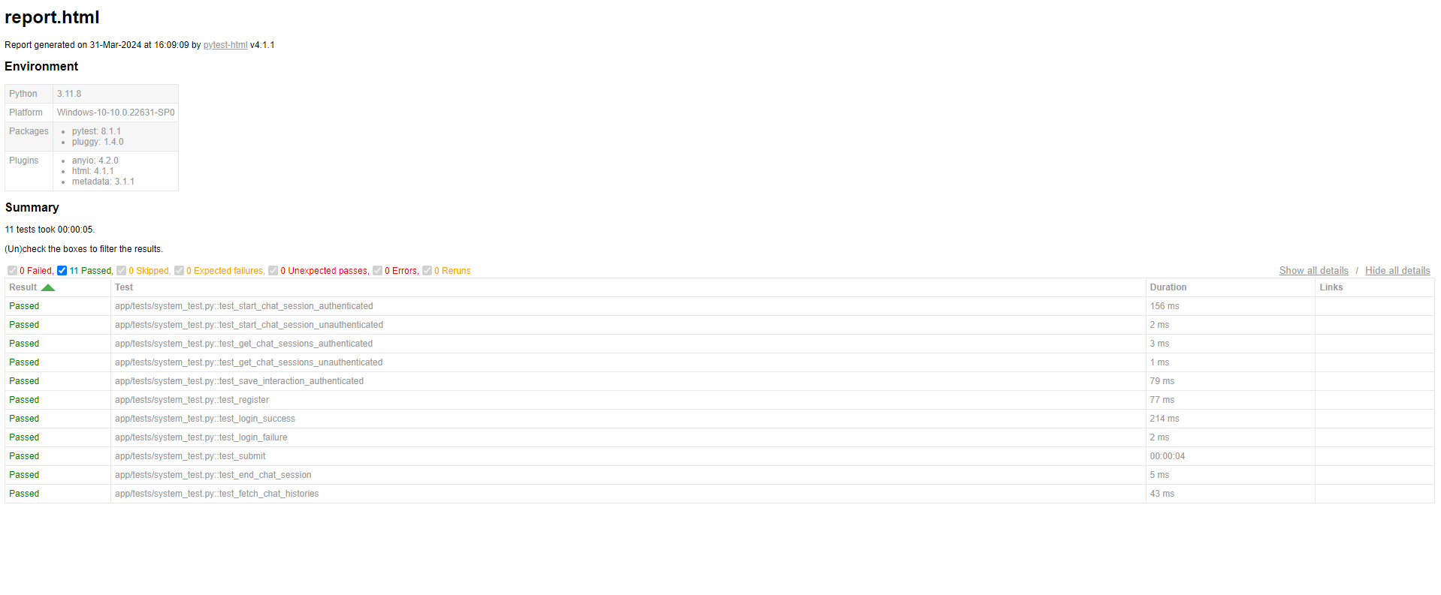

Figure Showing the results of pytest for Unit Tests

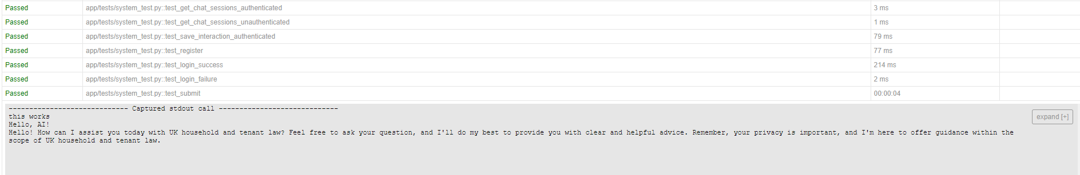

Figure Showing the Unit Test for Interation with Litigat8 NLP Model

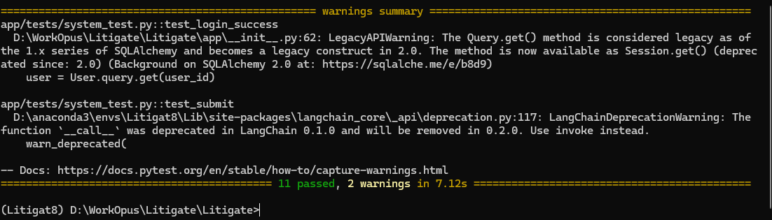

Figure Showing Warnings Generated by the Tests

## Unit Tests Outcome Discussion:

**Component Login(Success) :**

**func test_login_success:** The warning was originated from SQLALchemy. Which warned me about the Query.get() method has depreciated in the version 2.0 of the library. And instead advised me to use Session.get() instead to resolve the warning and any other compatibility issues in the future.

As a result, the login functions was updated to use the newer version of the function thus eliminating the warning for the test_login_success function



Figure Showing the Fix of Login (Success) component warning

**Component Submit (Authenticated):**

**func test_submit:**

The warning was originated from langchain_core_api warning about the deprecation of __call__ function within the version LangChain 0.1.0 and warning that it would be removed in 0.2.0. I wasn’t able to exactly pinpoint which method would be required to change as the error is not being originated from. But for the sake of this project and the version of LangChain that is being used for the project. It wouldn’t affect the functioning of the project.

## Integration Testing Plan:

Integration testing was carried out with the development of each sub system of the project to make sure that addition of a new functionality doesn’t compromise the stability of the system and doesn’t break it. The results of the integration testing were mostly positive as a result of through unit testing which reduced the number of problems to be face in the integration testing.

## Integration Testing Outcomes:



Table Showing Integration Test Outcome

# Evaluation:

There were two sets of objectives—primary and secondary—that defined the scope of the project. Primary objectives were of utmost importance for the success of the project, followed by secondary objectives. Following an agile solution approach with SCRUM outputs were produced during each sprint, serving as building blocks for the application, thus resulting in a fully functioning application. The resulting application demonstrates a wide variety of functional features, which, combined with the functional and non-functional system requirements analyzed by the MoSCoW Method, address the set four primary objectives. However, in the case of secondary objectives, two failed to be accomplished.

The **P1** objective, which stated the development of a User Interface that is intuitive and accessible, was accomplished. The objective was accomplished by following a proper agile solution approach with an emphasis on time management, where tools like the Trello board and Gantt Chart were used and helped me put a proper management system in place which led to the success of this objective. The objective was approached systematically, where the initial design was constructed using wireframes, which were then implemented in code to avoid any changes in design at a later stage. Following **P1**, the **P2** and **P3** objectives were put under development. The focus of **P2** was on developing a natural language processing system unit that could understand user queries and process them accurately in real-time. The accomplishment of this objective was challenging, as I had to work with many new technologies. However, thanks to proper time management and a sound solution approach, I was able to tackle it appropriately, thus producing a proof-of-concept NLP model capable of performing the set tasks using libraries such as LangChain, CTransformers, OpenAI(), etc. The **P3** objective was carried out in parallel, where many articles concerning household and tenant law were collected and integrated into the NLP model by creating vector databases. Most of the articles collected were in PDF format, thus the processing of this information was facilitated by libraries such as **PyPDF Loader**. Both of these objectives were completed systematically following the proper plan and designs set in place.

Moving on to the final primary objective, P4, real-time response generation technologies like JS Fetch Requests and Flask Server Handling were used to initiate requests, gather responses, and display them on the front-end. This enabled users to receive advice from the AI in real-time. Comparative studies were also conducted to find the best model and parameters for quick advice, which resulted in the best configuration of the model, thus enabling the accomplishment of this objective.

When it comes to secondary objectives, **S1** was achieved partly due to most resources and time being allocated to achieving the primary objectives. Steps were taken to make the application accessible as possible but I feel like there is still room for lot of development. The objective that wasn’t accomplished was **S4**, to establish a feedback system for the model in such a way that it would remember the conversation with the user and use that as context for the conversation, which will still be part of the future development of the project. Objectives **S2** and **S3** were accomplished by setting up an authentication model with ample security measures, such as locking the URLs and using **Bcrypt** to encrypt all passwords for users, signifying the successful completion of these objectives.

Using the Scrum project solution approach, I was able to tackle all the problems I faced in a timely manner. Putting in place a proper time management system ensured that I was able to accomplish my objectives on time, whether they were primary or secondary. Through requirement analysis and planning, I was able to prioritize all objectives that were of prime importance for the success of the project. Using these techniques, I was able to complete the project and produce a proof-of-concept application that met the objectives set out for it, which I am really proud of. These techniques ensured that if any problems arose, there would be a failsafe in place

# Future Work:

There are number of areas that could be improved in the scope of this project. Which I believe can be implemented to make the system more robust and have a lot more features than it currently has.

The first improvement that would be implemented in the future for this application would be to establish a **feedback system** along with chat remembering feature for the AI so that the user could have a conversation with the model and gradually improve the output the model results in. And the feedback would make the model learn and gradually improve its performance.

The second improvement that would be implemented will be an **online vector database** to increase its accessibility across devices. One of the implementations of it was explored but was failed to be implemented for the current application. So, I would like to explore alternatives such as Weaviate to implement it. Thus adding more versatility to the project.

The third improvement would be to explore models like **Grok** to implement the functionality as this model can support upwards of 314 billion parameters with context token size of 8K tokens. Which is great improvement from gpt-3.5-turbo model but still relatively less effective than GPT-4 and I want to test if this can server as a better option relative to gpt-3.5-turbo model in response time.

The fourth improvement I would like to make it is to increase the information available in the dataset and focus on **other domains of law** as well which I feel like would provide more utility instead of just focusing on a single domain but given the restraint of time and resources for this proof-of-concept application it couldn’t be implemented in this development phase but if this application is decided to work on this improvement would be implemented.

The fifth improvement would be to make the response that’s generated out of the model should be more structured with headings and sub-headings which I believe would be done with the help of **markdown language**. This would make the advice look more readable and more understandable for the user.

The sixth area of development would be supporting **file uploads to proof-read-contracts** or even draw up contracts for you like tenancy agreement and such. Which I believe would provide a lot of utility to the users and hence would greatly increase user satisfaction. And I feel like this area would make Litigat8 stand out and provide real utility to the users.

These are some of the key areas of improvements that could be worked on to improve the litigat8’s application and functionality. If decide to work on the application beyond proof-of-concept then all of these improvement areas would be analysed and worked on and would be implemented in the real-world application.

# Conclusion:

To conclude the development of the project and the planning and management that was put into place for it, it is evident from the report that as the sole developer of the Litigat8 project, the set NLP application was successfully developed.

The application resulted after the development as able to successfully provide basic legal adive to the users and it was also able to provide case law references of certain queries depending on their availability. The users were successfully able to register/login to the application to use the features and the users could also look back at there chat history and review all the conversation that they had with the NLP model.

All of the features that were implemented in the application were tested and made sure that they perform the task related to them without any problem. The user interphase that was implemented was properly planned with lots of design principles and patterns kept in mind

All the set objectives were attained through using the scrum framework. Where in each scrim priority was given to an objective that was planned for that specific sprint in the sprint planning session. All though there was lots of problems along the way many technological hurdles and obstacles but thanks to the flexibility of scrum framework I was able to tackle them with an iterative approach and each.

Despite failing to achieve S4 objective to implement a feedback system due to lack of time and enough domain knowledge, using of techniques such as MoSCoW analysis and Functional and Non Functional requirements I was able to implement the features that were of utmost important for the success of this project.

Finally, in case of litigat8 there are number of gaps left still to be filled or improved upon and some of which have been discussed in this report however the room of improvement is unlimited.

# References

1. Khurana D, Koli A, Khatter K, Singh S. Natural language processing: state of the art, current trends and challenges. Multimed Tools Appl. 2023;82(3):3713-3744. doi: 10.1007/s11042-022-13428-4. Epub 2022 Jul 14. PMID: 35855771; PMCID: PMC9281254.(for Image and the introduction)
2. Sutskever, I., Vinyals, O., and Le, Q.V. (2014) 'Sequence to Sequence Learning with Neural Networks', in Proceedings of the 27th International Conference on Neural Information Processing Systems - Volume 2 (NIPS'14), MIT Press, Cambridge, MA, USA, pp. 3104–3112.
3. and Short Papers), pp. 4171–4186.
4. Hutchins, W.J. (1986) 'Machine Translation: Past, Present, Future', Ellis Horwood, Chichester, England.
5. Hutchins, W.J. (1995) 'Machine Translation: A Brief History', in Concise History of the Language Sciences: From the Sumerians to the Cognitivists, pp. 431–445.
6. Radford, A., Wu, J., Child, R., Luan, D., Amodei, D., and Sutskever, I. (2019) 'Language Models are Unsupervised Multitask Learners', OpenAI Blog.
7. Winograd, T. (1972) 'Understanding Natural Language', Academic Press, New York, NY.
8. Hassler, M., & Fliedl, G. (2006). Text Preparation Through Extended Tokenization.(for tokensation images)
9. [https://www.freecodecamp.org/news/an-introduction-to-part-of-speech-tagging-and-the-hidden-markov-model-953d45338f24/](https://www.freecodecamp.org/news/an-introduction-to-part-of-speech-tagging-and-the-hidden-markov-model-953d45338f24/(linke) (link for the pos image
10. Goodfellow, I., Bengio, Y., and Courville, A. (2016) 'Deep Learning', MIT Press, Cambridge, MA, USA.
11. Vaswani, A. et al. (2017) 'Attention is All You Need', in Proceedings of the 31st International Conference on Neural Information Processing Systems, pp. 5998–6008.
12. <https://www.codemotion.com/magazine/video/nlp-techniques-and-deep-learning/> (image for machine learning in NLP)
13. <https://sonix.ai/articles/difference-between-artificial-intelligence-machine-learning-and-natural-language-processing(image> for machine learning in NLP
14. Barocas, S., Hardt, M., and Narayanan, A. (2019) 'Fairness and Abstraction in Sociotechnical Systems', in Proceedings of the Conference on Fairness, Accountability, and Transparency, pp. 59–68.
15. Romanosky, S. (2016) 'Examining the Costs and Causes of Cyber Incidents', Journal of Cybersecurity, 2(2), pp. 121–135.
16. Voigt, P., and Von dem Bussche, A. (2017) 'The EU General Data Protection Regulation (GDPR)', Springer International Publishing, Cham.
17. Ashley, K.D. (2017) 'Artificial Intelligence and Legal Analytics: New Tools for Law Practice in the Digital Age', Cambridge University Press, Cambridge.
18. Branting, L.K. (2021) 'Explainable Artificial Intelligence and the Interpretability Problem in Legal Analytics', Jurimetrics, 61, pp. 45–68.
19. Kreutzer, R.T., and Sirrenberg, M. (2019) 'Understanding Artificial Intelligence: A Guide for Business Leaders', Springer Nature, Cham.
20. Tsarapatsanis, D., and Aletras, N. (2021) 'Machine Learning in Law: Present and Future', in Artificial Intelligence and Law, 29, pp. 355–385.
21. Zhong, H., Guo, Z., Tu, C., Xiao, C., Liu, Z., and Sun, M. (2020) 'How Does NLP Benefit Legal System: A Summary of Legal Artificial Intelligence', in Proceedings of the 58th Annual Meeting of the Association for Computational Linguistics, pp. 5218–5230.
22. Alarie, B., Niblett, A., and Yoon, A.H. (2018) 'How Artificial Intelligence Will Affect the Practice of Law', University of Toronto Law Journal, 68(S1), pp. 106–124.
23. Katz, D.M., Bommarito II, M.J., and Blackman, J. (2017) 'A General Approach for Predicting the Behavior of the Supreme Court of the United States', PLoS One, 12(4), e0174698.
24. Rule, C. (2017) 'Online Dispute Resolution for All: The History and Future of Online Dispute Resolution', in Online Dispute Resolution: Theory and Practice, Eleven International Publishing, The Hague, pp. 13–32.
25. Sourdin, T. (2018) 'Judge v. Robot? Artificial Intelligence and Judicial Decision-Making', University of New South Wales Law Journal, 41(4), pp. 1114–1133.
26. <https://www.itv.com/news/2024-02-08/number-of-no-fault-evictions-hit-eight-year-high-new-data-shows>
27. <https://www.insidehousing.co.uk/news/large-councils-disrepair-cases-up-1584-in-five-years-83281>
28. https://www.nimblefins.co.uk/number-homeowners-and-renters-uk#:~:text=Number%20of%20Renters%20UK,private%20renters%20than%20social%20renters.

# Dataset Document Reference:

1. Carr, Helen and Cowan, Dave, The Social Tenant, the Law and the UK's Politics of Austerity (February 16, 2015). Oñati Socio-Legal Series, Vol. 5, No. 1, 2015, Available at SSRN: <https://ssrn.com/abstract=2565733>
2. Andy Dickerson, Emily McDool & Damon Morris. (2023) [Post-compulsory education pathways and labour market outcomes](https://www.tandfonline.com/doi/full/10.1080/09645292.2022.2068137). *Education Economics* 31:3, pages 326-352.
3. Peta Wolifson, Sophia Maalsen & Dallas Rogers. (2023) [Intersectionalizing Housing Discrimination Under Rentier Capitalism in an Asset-Based Society](https://www.tandfonline.com/doi/full/10.1080/14036096.2022.2163283). *Housing, Theory and Society* 40:3, pages 335-355.
4. Moore, T. and Dunning, R., 2017. Regulation of the private rented sector in England using lessons from Ireland. JRF Report, Joseph Rowntree Foundation, York
5. Flint, J., 2004. The responsible tenant: Housing governance and the politics of behaviour. *Housing studies*, *19*(6), pp.893-909.
6. Ball, M., 2010. The UK private rented sector as a source of affordable accommodation. York: Joseph Rowntree Foundation.
7. Power, E. R. and Gillon, C. (2022) ‘Performing the ‘good tenant’’, Housing Studies, 37(3), pp. 459–482. doi: 10.1080/02673037.2020.1813260.
8. McKee, K., Muir, J. and Moore, T. (2017) ‘Housing policy in the UK: the importance of spatial nuance’, Housing Studies, 32(1), pp. 60–72. doi: 10.1080/02673037.2016.1181722.
9. Hilber, Christian A. L. (2015) UK housing and planning policies: the evidence from economic research. Election Analysis (33). Centre for Economic Performance, The London School of Economics and Political Science, London, UK.
10. Rolfe, S. et al. (2023) ‘The role of private landlords in making a rented house a home’, International Journal of Housing Policy, 23(1), pp. 113–137. doi: 10.1080/19491247.2021.2019882.
11. S. Moffatt, S. Lawson, R. Patterson, E. Holding, A. Dennison, S. Sowden, J. Brown, A qualitative study of the impact of the UK ‘bedroom tax’, *Journal of Public Health*, Volume 38, Issue 2, June 2016, Pages 197–205, <https://doi.org/10.1093/pubmed/fdv031>
12. Hulse, K. and Haffner, M. (2014) ‘Security and Rental Housing: New Perspectives’, *Housing Studies*, 29(5), pp. 573–578. doi: 10.1080/02673037.2014.921418.
13. Murie, A. (1997) ‘The social rented sector, housing and the welfare state in the UK’, *Housing Studies*, 12(4), pp. 437–461. doi: 10.1080/02673039708720909.
14. Stone, M. E. (2006) ‘A Housing Affordability Standard for the UK’, *Housing Studies*, 21(4), pp. 453–476. doi: 10.1080/02673030600708886.
15. Harris, J. and McKee, K., 2021. Health and Wellbeing in the UK Private Rented Sector: enhancing capabilities. *Glasgow, UK: UK Collaborative Centre for Housing Evidence (CaCHE)*.
16. Harris, J. and McKee, K., 2021. Health and Wellbeing in the UK Private Rented Sector: enhancing capabilities. Glasgow, UK: UK Collaborative Centre for Housing Evidence (CaCHE).
17. Kemp, P. A. (2011) ‘Low-income Tenants in the Private Rental Housing Market’, Housing Studies, 26(7–8), pp. 1019–1034. doi: 10.1080/02673037.2011.615155.
18. Jordan M. Contesting the property paradigm amid ‘radical’ constitutional change: Living Rent and the Private Residential Tenancies (Scotland) Act 2016. *Legal Studies*. Published online 2024:1-18. doi:10.1017/lst.2024.4
19. Lister, D. (2006). Unlawful or just awful? Young people’s experiences of living in the private rented sector                in England. YOUNG, 14(2), 141-155. <https://doi.org/10.1177/1103308806062738>
20. Powell, R. (2015) ‘Housing Benefit Reform and the Private Rented Sector in the UK: On the Deleterious Effects of Short-term, Ideological “Knowledge”’, *Housing, Theory and Society*, 32(3), pp. 320–345. doi: 10.1080/14036096.2015.1027830.
21. Green, G., Barratt, C. and Wiltshire, M. (2016) ‘Control and care: landlords and the governance of vulnerable tenants in houses in multiple occupation’, *Housing Studies*, 31(3), pp. 269–286. doi: 10.1080/02673037.2015.1080818.
22. Badarinza, Cristian and Ramadorai, Tarun, Long-Run Discounting: Evidence from the UK Leasehold Valuation Tribunal (October 26, 2015). Available at SSRN: <https://ssrn.com/abstract=2412296> or [http://dx.doi.org/10.2139/ssrn.2412296](https://dx.doi.org/10.2139/ssrn.2412296)
23. Feijten, P., & van Ham, M. (2010). The Impact of Splitting Up and Divorce on Housing Careers in the UK. *Housing Studies*, *25*(4), 483–507. <https://doi.org/10.1080/02673031003711477>.
24. Morgan, J. (2001) ‘Nuisance and the Unruly Tenant’, The Cambridge Law Journal, 60(2), pp. 382–404. doi:10.1017/S0008197301000162.
25. Coulter, Rory, and Michael Thomas. “A New Look at the Housing Antecedents of Separation.” Demographic Research, vol. 40, 2019, pp. 725–60. JSTOR, https://www.jstor.org/stable/26727015. Accessed 4 Apr. 2024.
26. Easthope, H. (2014) ‘Making a Rental Property Home’, *Housing Studies*, 29(5), pp. 579–596. doi: 10.1080/02673037.2013.873115.
27. Soaita, A. M. et al. (2017) ‘Becoming a landlord: strategies of property-based welfare in the private rental sector in Great Britain’, Housing Studies, 32(5), pp. 613–637. doi: 10.1080/02673037.2016.1228855.
28. Martin, C., 2004. Law and Order in Public Housing: the Residential Tenancies Amendment (Public Housing) Act 2004 (NSW). *Current Issues in Criminal Justice*, *16*(2), pp.226-232.
29. Tunstall, R. (2003) ‘‘Mixed tenure’ policy in the UK: privatisation, pluralism or euphemism?’, *Housing, Theory and Society*, 20(3), pp. 153–159. doi: 10.1080/14036090310019445.
30. Gibb, K. (2015) ‘The multiple policy failures of the UK bedroom tax’, *International Journal of Housing Policy*, 15(2), pp. 148–166. doi: 10.1080/14616718.2014.992681.
31. Shankley, W. and Finney, N., 2020. Ethnic minorities and housing in Britain. In Ethnicity, Race and Inequality in the UK (pp. 149-166). Bristol: Policy Press.
32. Adriana Mihaela Soaita, Kim McKee,Assembling a ‘kind of’ home in the UK private renting sector, Geoforum, Volume 103,2019,Pages 148-157,ISSN 0016-7185,https://doi.org/10.1016/j.geoforum.2019.04.018.
33. Carr, H., 2002. Renting Homes 2: Co-Ocupation, Transfer and Succession. A Consultation Paper. The Stationary Office.
34. <https://www.landmarkchambers.co.uk/wp-content/uploads/2018/07/Landlord-and-Tenant-Recent-Cases-John-Male-QC-Katharine-Holland-QC.pdf>
35. Law Commission, 1996. Landlord and tenant: Responsibility for State and Condition of Property. The Law Commission, London.
36. <https://www.camden.gov.uk/documents/20142/2134745/Rent+Repayment+Order-Tenants+Guide.pdf/03d9c275-6cca-c7ab-0363-34e72fc0409f>
37. <https://researchbriefings.files.parliament.uk/documents/SN01998/SN01998.pdf\>